CSCU9YW Web Services – Assignment Report

Student ID: 2634056

Table of Contents

Table of Figures 2

1. Overview 3

2. Implementation 3

2.1. GUI 3

2.1.1. Get Contact 4

2.1.2. Inserting Contact 7

2.1.3. Modify Contact 12

2.1.4. Delete Contact 16

2.2. Error Handling 19

2.2.1. ErrorFault at RetrieveContact 19

2.2.2. ErrorFault trying to insert contact with a phone number pre-existent 20

3. Additional Comments 20

4. Appendix 21

4.1. ContactService.wsdl 21

4.2. ContactRetrieverService.java 24

4.3. ContactManager.java 28

4.4. UI.java 30

4.5. InsertContactDialog.java 38

4.6. ModifyContactDialog.java 44

# Table of Figures

Figure 1 - The GUI 3

Figure 2 – Get Contact 4

Figure 3 – Empty Field Error Message 5

Figure 4 – Found Contact Display 6

Figure 5 – Get Request Wireshark 6

Figure 6 – Get Response Wireshark 7

Figure 7 – Insert Button 8

Figure 8 – Insert Dialog 8

Figure 9 – Insert Empty Field Error 9

Figure 10 – Insert Pre-existing phone number 9

Figure 11 – Insert Success Message 10

Figure 12 – Insert Contact Display 11

Figure 13 – Insert in Wireshark 12

Figure 14 – Modify Button 13

Figure 15 – Modification Dialog 13

Figure 16 – Modify Confirmation Message 14

Figure 17 – Modification Success Message 14

Figure 18 – Modified Contact Display 15

Figure 19 – Modification Get Wireshark 15

Figure 20 – Modification Request Wireshark 16

Figure 21 – Delete Button 17

Figure 22 – Delete Confirmation Message 18

Figure 23 – Delete Success Message 18

Figure 24 – Get ErrorFault Wireshark 19

Figure 25 – Insert ErrorFault Wireshark 20

# Overview

The aim of the project was to use a web service to maintain a list of contacts from a database. The web service should handle adding, retrieving, modifying and deleting contacts. The basic information required about a contact is their last name, first name, address, and telephone number, where the phone number is their identification number.

At the end of the document is attached my code. I have only attached the classes that I have created, and did not include the files that get generated by the WSDL file.

# Implementation

For the assignment, I decided to work from lab 3, using SOAP and Axis2.

I implemented all the required features and implemented a couple of extra features, such as a graphical interface and special error handling.

My web service connects to a local database by using a MySQL connector. This required me to set up a MySQL workbench that my Web service could interact with using an external jar. The jar had to be uploaded to tomcat in order to interact.

## GUI

The following figure displays an overview of the GUI the Client can interact with (*see Figure 1)*. 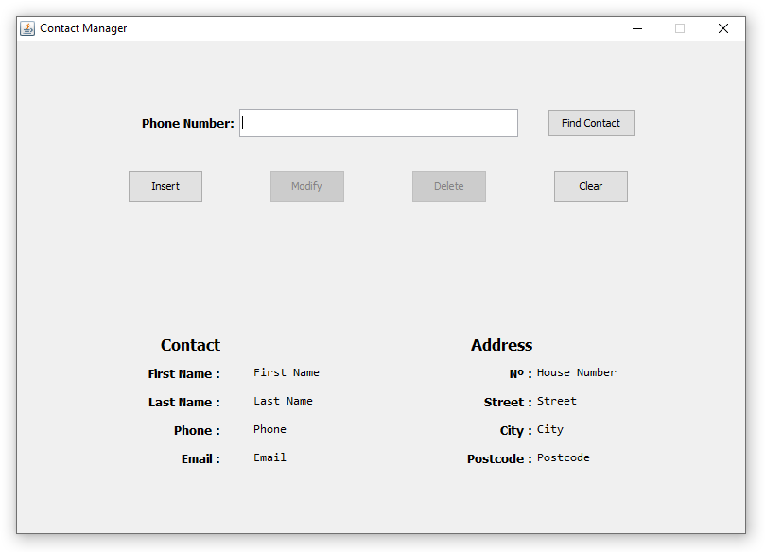

Figure - The GUI

### Get Contact

At the start of the application, the user is given the option to research a contact by inserting the phone number of the contact they are trying to find. Once they filled the field, they can call for the search by pressing the “Find Contact” button *(see Figure 2)*. This will prompt the service for a contact with the passed phone number from the database.

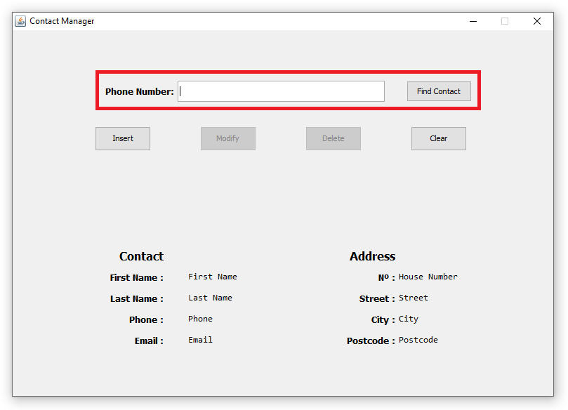

Figure – Get Contact

If the client does not exist in the database, the service will throw an Error Fault, which is handled by the client and displays a JOptionPane dialog for the user *(see Figure 3)*. The UI also handles an empty input and displays a JOptionPane alerting the user that the field cannot be empty.

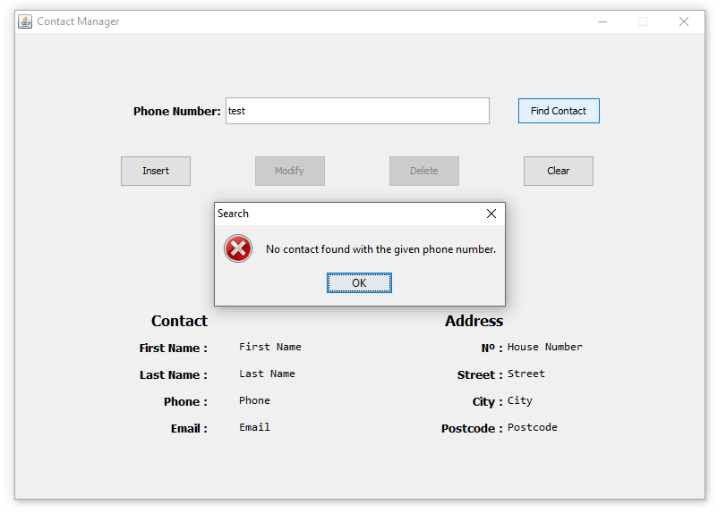

Figure – Empty Field Error Message

If the service finds a contact associated with the phone number, it will return the Contact object and print its fields in the frame for clearer display. The buttons modify and delete will also become enabled, allowing the visible contact to be modified or deleted.

The user can decide to clear the frame, which will empty all the display fields and the search field. It will also disable the modify and delete buttons, as no contact is currently selected.

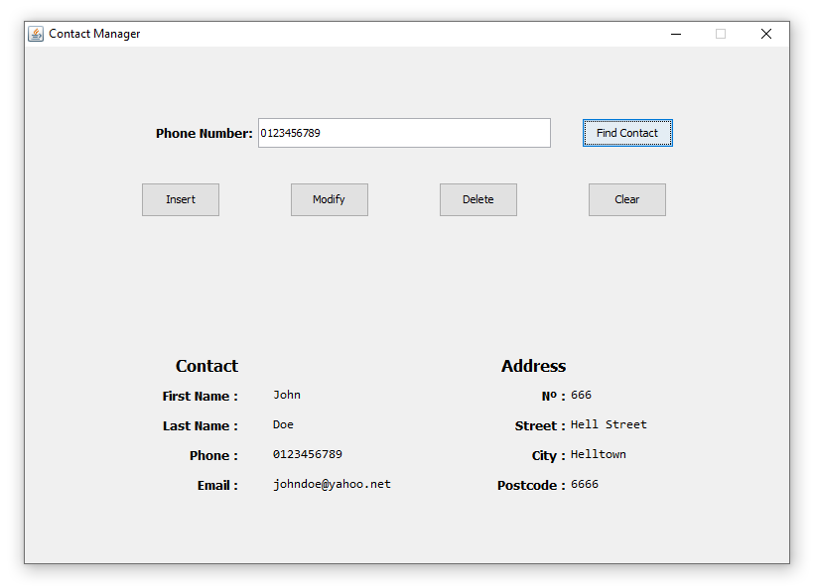

Figure – Found Contact Display

Getting a contact produces the following message in Wireshark *see Figure 5* and *Figure 6*.

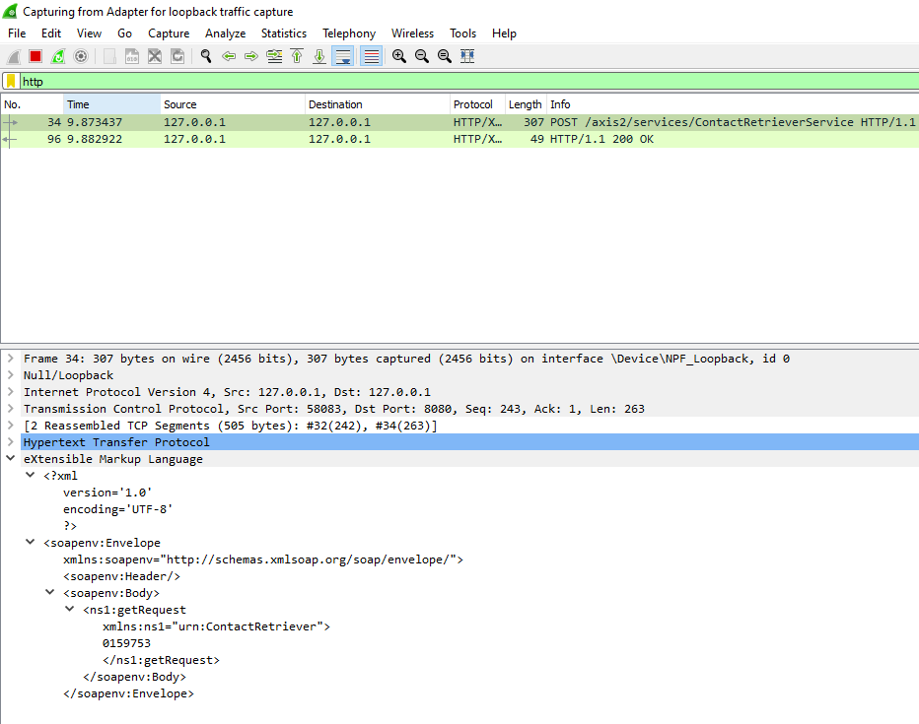

Figure – Get Request Wireshark

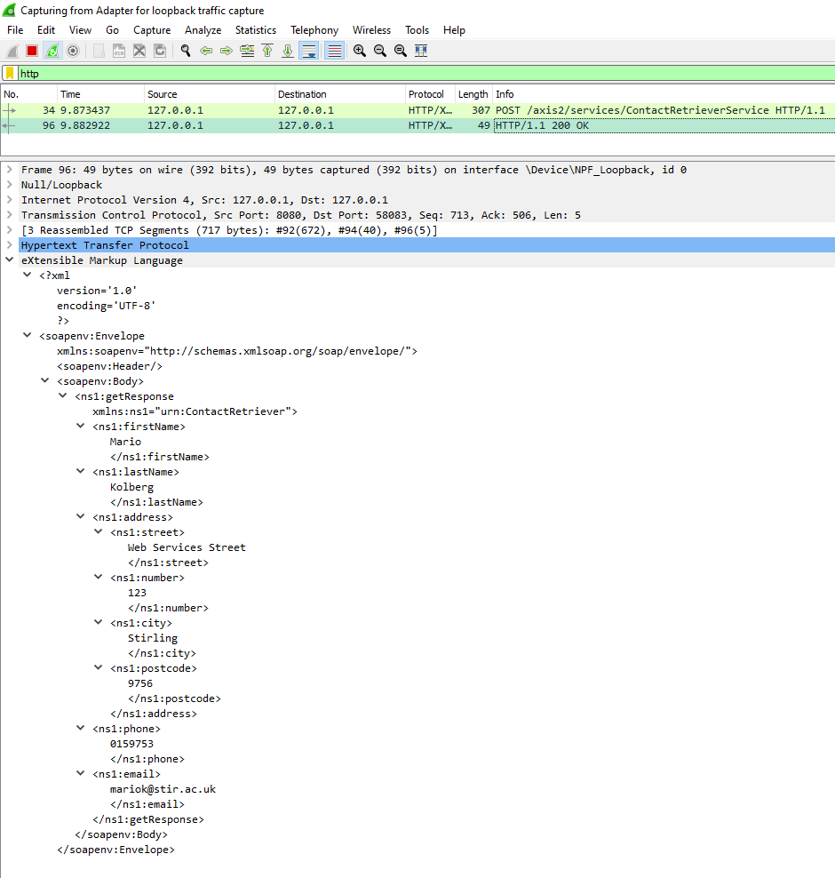

Figure – Get Response Wireshark

### Inserting Contact

When the user clicks on the “Insert” button (*see Figure 7*), it will open the InsertContactDialog (*see Figure 8*). In there, the client can enter all the details for the new contact. if any field is left empty, the UI will inform the user that some fields are empty and need to be filled(*see Figure 9*). If the phone number passed already exists in the database, the UI will inform that they need to input a different number (*see Figure 10*).

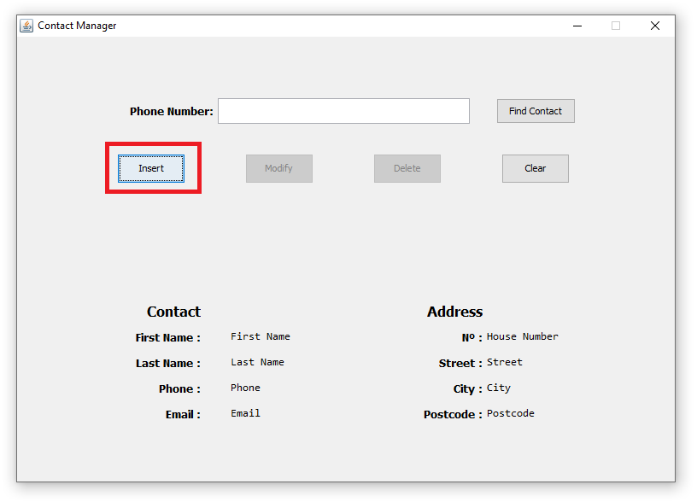

Figure – Insert Button

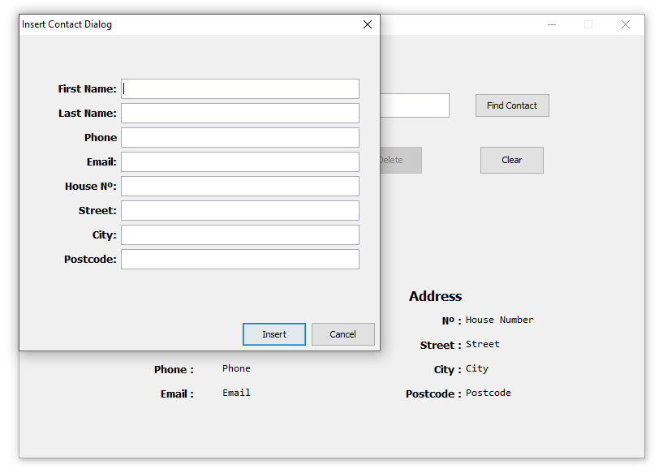

Figure 8 – Insert Dialog

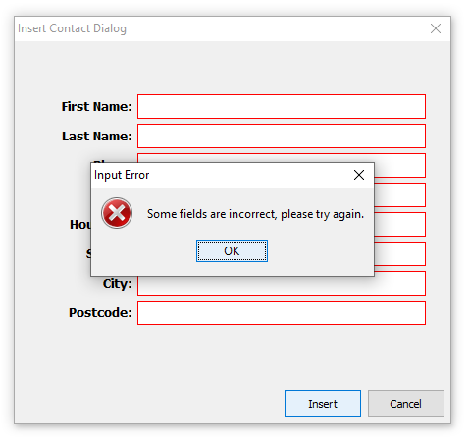

Figure 9 – Insert Empty Field Error

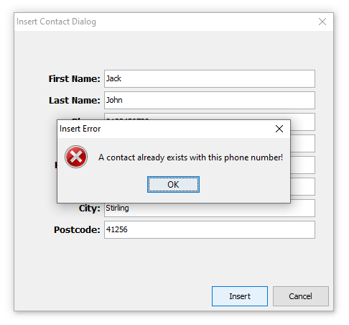

Figure – Insert Pre-existing phone number

Once all fields are correct, the UI will open a JOptionPane dialog to inform the user that the contact has been inserted into the database (*see figure 11*), and it will set the values of the display frame to the inserted contact (*see figure 12*) It will also enable the modify and delete buttons.

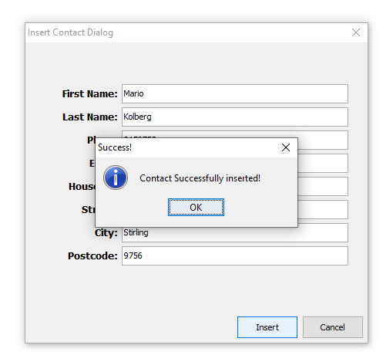

Figure 11 – Insert Success Message

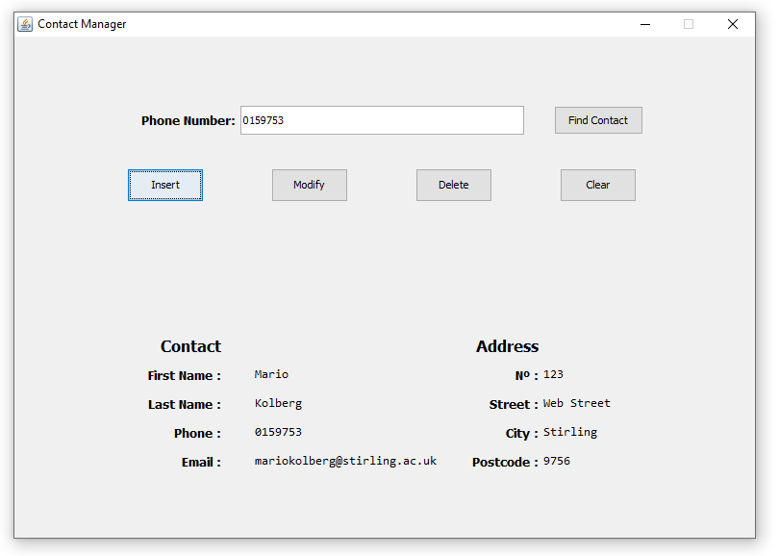

Figure 12 – Insert Contact Display

This is the Wireshark messages when inserting a new contact (*see Figure 13*).

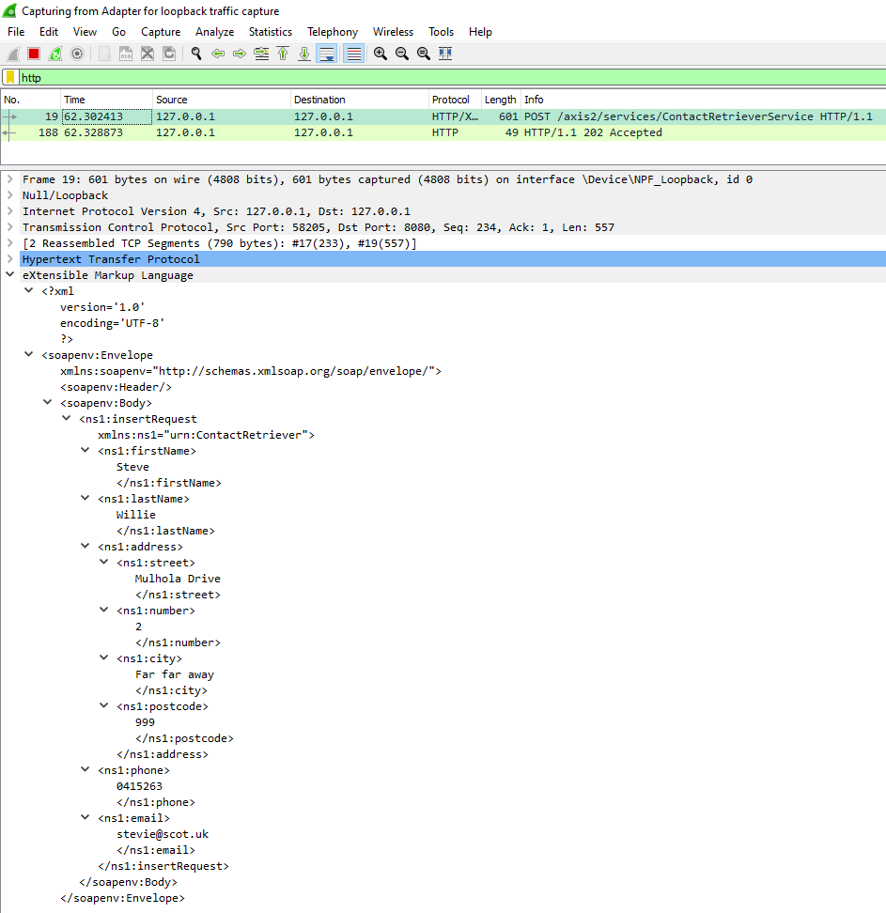

Figure – Insert in Wireshark

### Modify Contact

To modify the information of a contact, the user needs to have searched a contact first. Once a contact has been retrieved, the button “Modify” is enabled and the user can open the Modify dialog (*see Figure 14*). From this dialog, the user can set the new value of each field in the JTextField on the right (*see Figure 15)*.

The phone field is disabled to prevent the user to be able to change it. It is worth noting that any field left blank will retain its previous value. If the user clicks the button “Modify” in the dialog window, it will prompt the user for confirmation (*see Figure 16*), before sending the edited contact to the web service to update the database.

Finally, the UI displays a confirmation message (*see Figure 17*) and set the contact display in the main frame to the newly modified contact (*see Figure 18*).

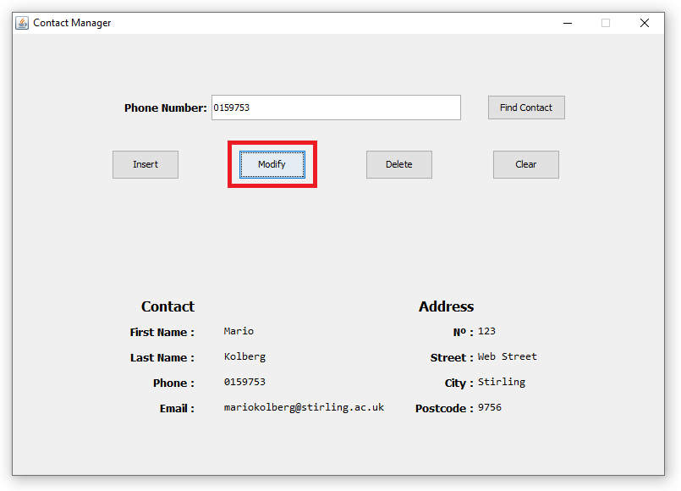

Figure 14 – Modify Button

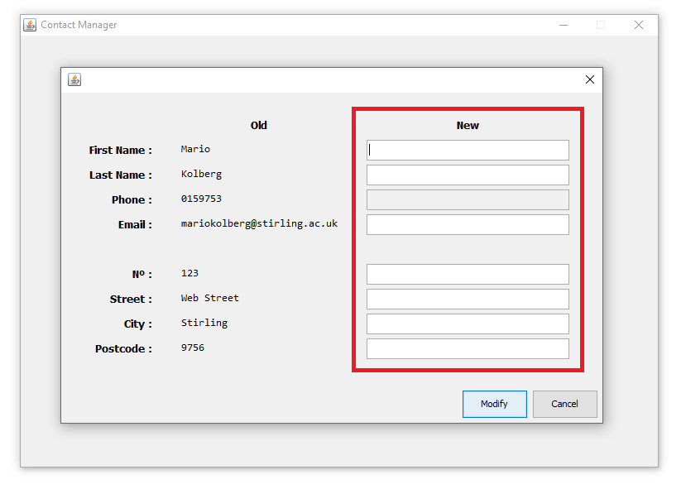

Figure 15 – Modification Dialog

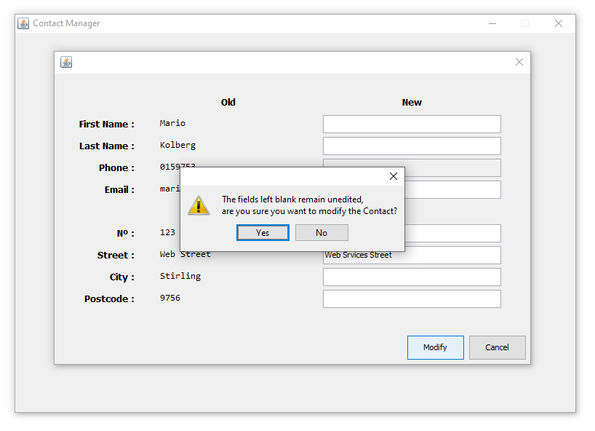

Figure – Modify Confirmation Message

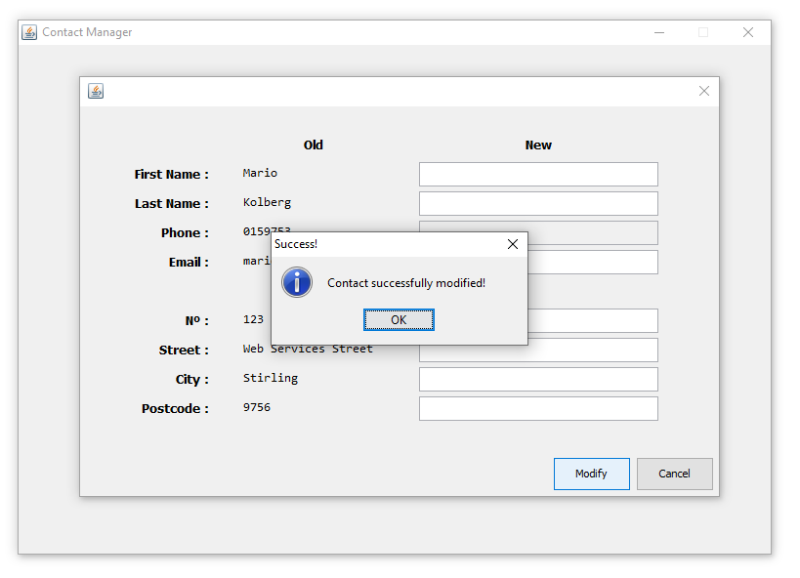

Figure – Modification Success Message

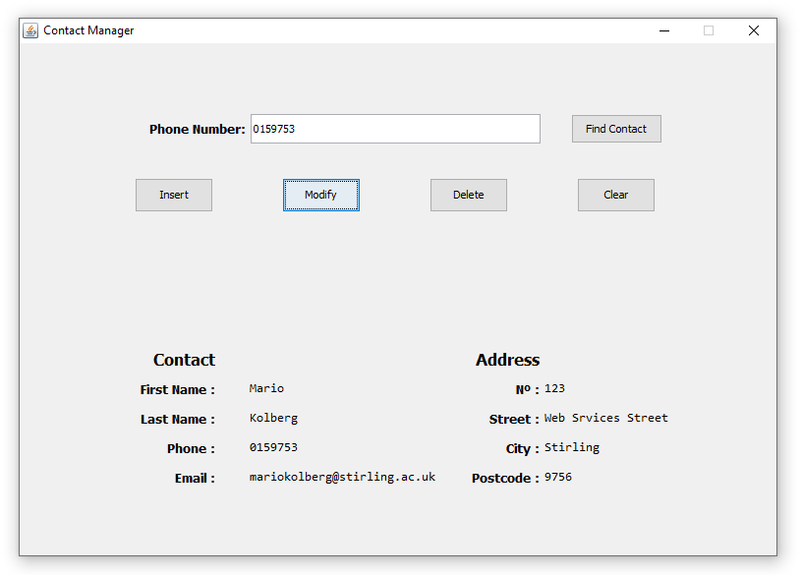

Figure – Modified Contact Display

This is the Wireshark messages when inserting a new contact (*see Figure 19 and 20*).

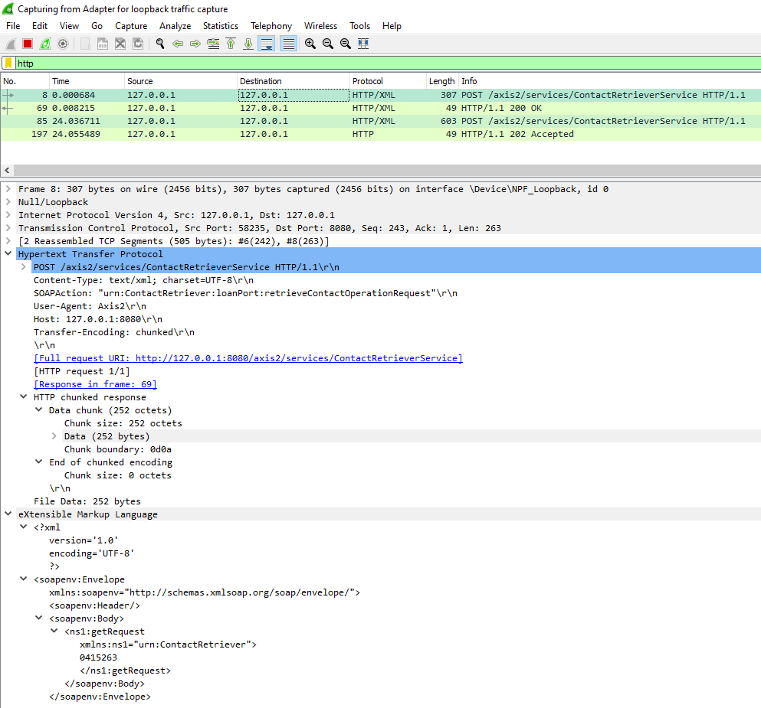

Figure – Modification Get Wireshark

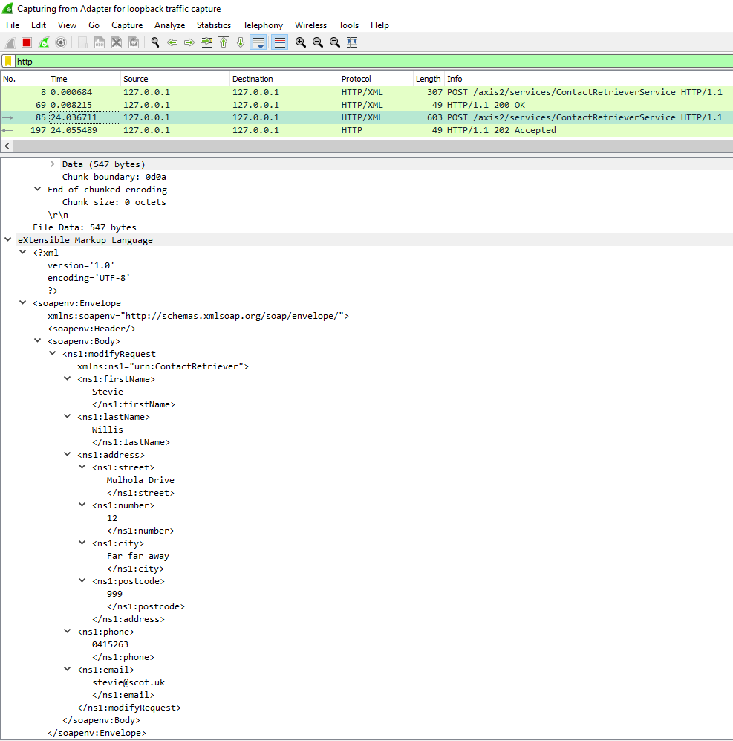

Figure – Modification Request Wireshark

### Delete Contact

To delete a contact, the user needs to have searched a contact first. Once the contact has been retrieved, the button “Delete” is enabled and the user can delete the Contact shown (*see Figure 21*).

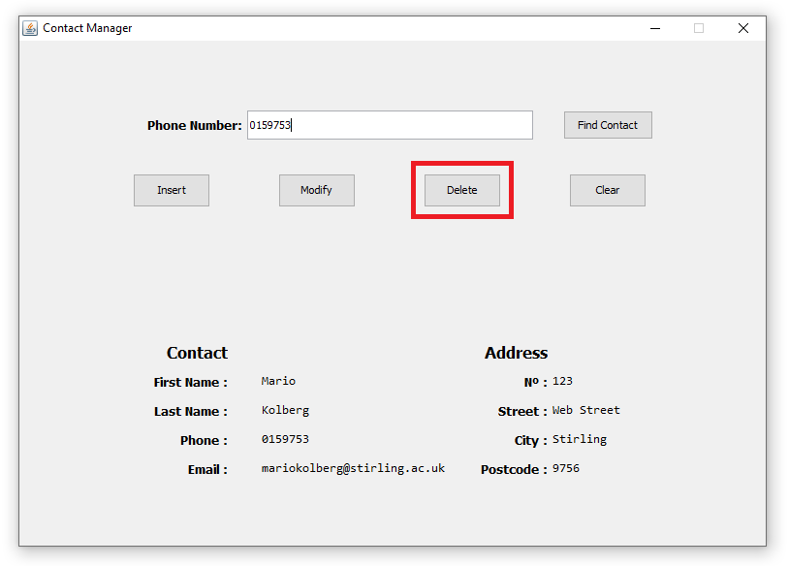

Figure – Delete Button

The UI will then prompt a confirmation dialog (*see Figure 22*) to the user before sending the request to the web service to delete the Contact from the database. Once the contact has been deleted, the UI displays a confirmation dialog (*see Figure 23*).

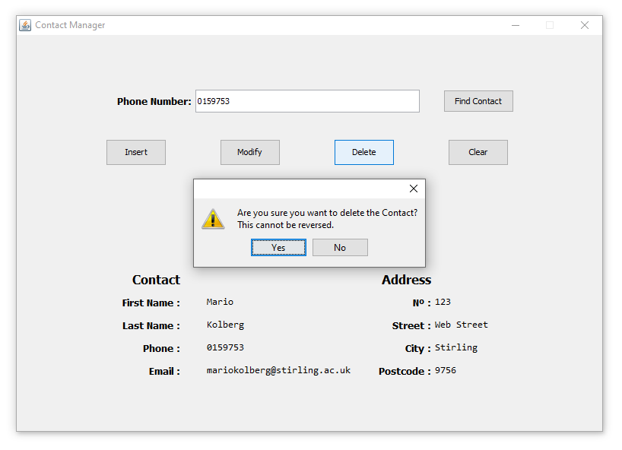

Figure – Delete Confirmation Message

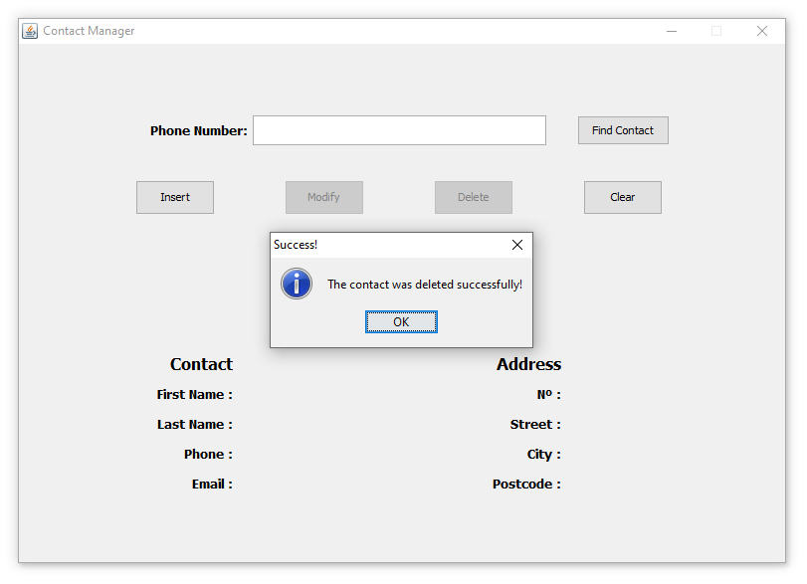

Figure – Delete Success Message

## Error Handling

The web service will throw ErrorFault with appropriate messages when there is an inappropriate input, when the user is trying to find a non-existent contact, or when the user is trying to insert a new contact with a pre-existent phone number.

Initially, I implemented the feature that an error would get thrown when trying to delete or modify a user that does not exist. I changed this design because I found it more ergonomic to have this handled at the UI stage. The error handling is however still visible in the ContactService class in the modifyContactOperation and deleteContactOperation.

### ErrorFault at RetrieveContact

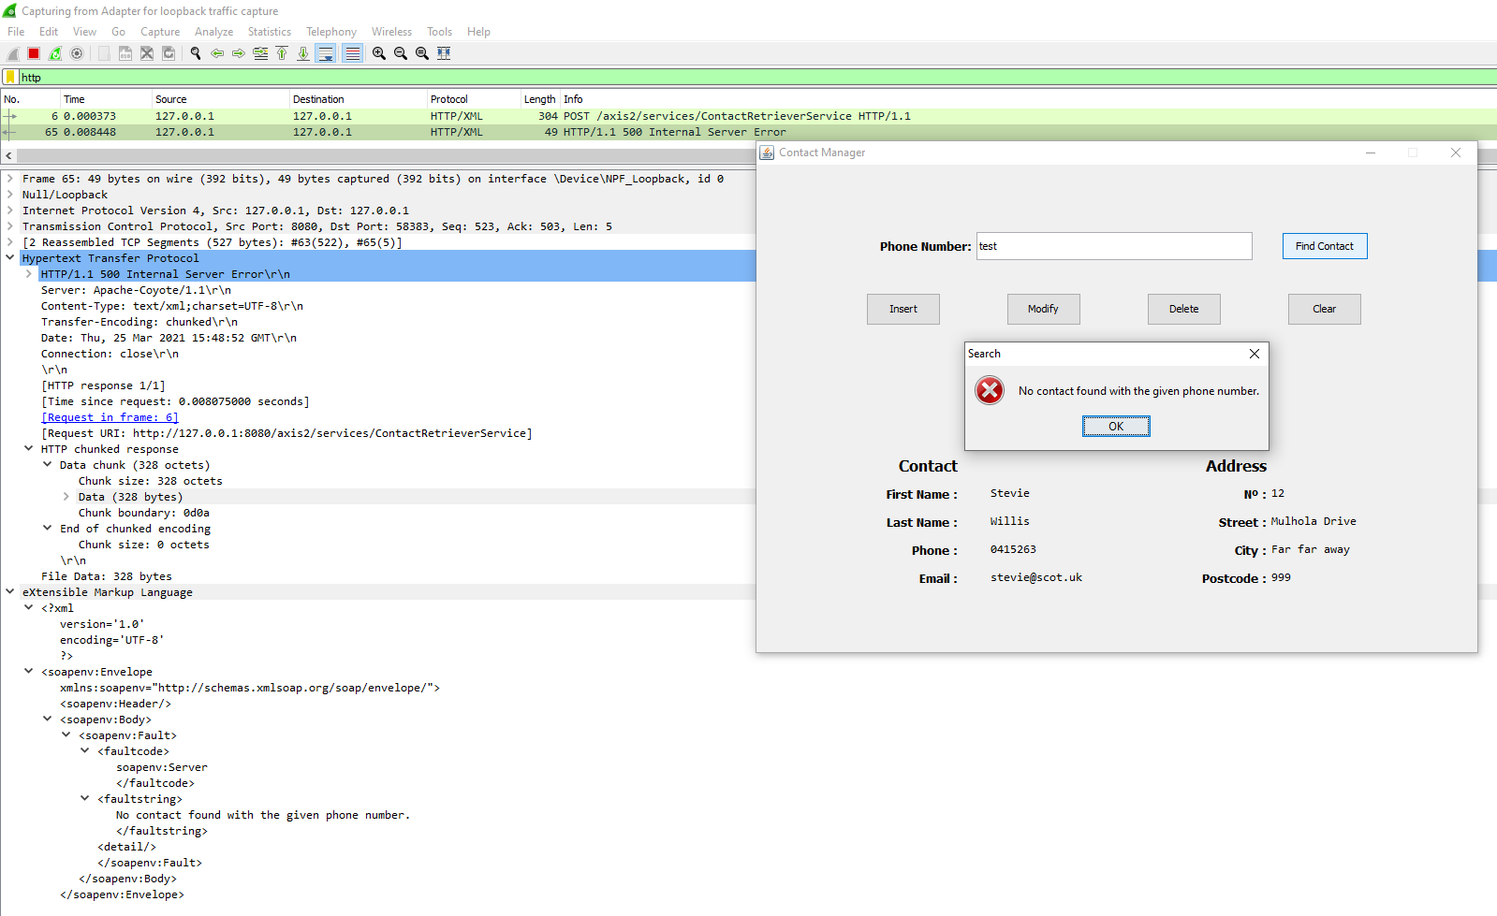

Figure – Get ErrorFault Wireshark

### ErrorFault trying to insert contact with a phone number pre-existent

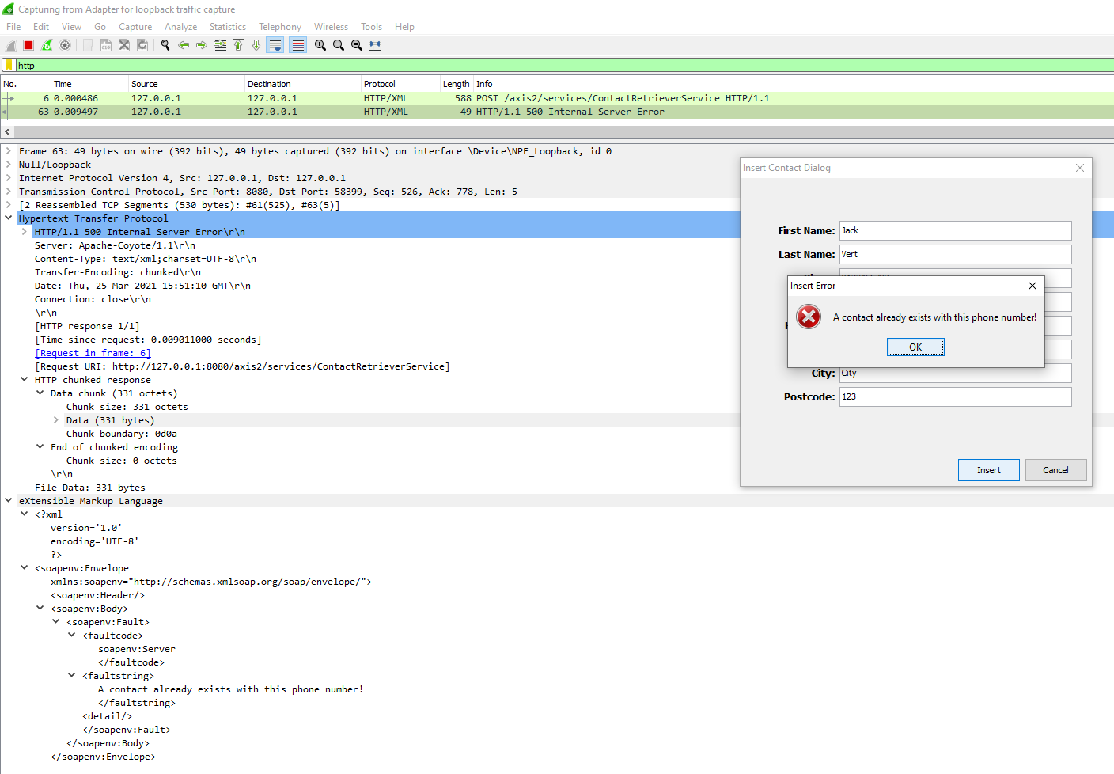

Figure – Insert ErrorFault Wireshark

# Additional Comments

Due to a lack of time and preparation, I have not implemented any input validation in the sense of what the user types into these boxes. This is obviously a big security risk, as a user could easily insert SQL injection into the fields and break the system/database. Besides the SQL injection, a user could enter a value totally different from a typical phone number into the phone number field, and the system would never consider it incorrect, which can create inconsistent data in the storage.

I have however decided that those were not the aim and goal of this assignment and that they were in no way a necessity, but instead would be interesting features for further implementations.

# Appendix

Here is the appendix of my code.

## ContactService.wsdl

<?xml version=**"1.0"** encoding=**"UTF-8"**?>

<definitions name=**"ContactRetrieverDefinitions"**

targetNamespace=**"urn:ContactRetriever"** xmlns=**"http://schemas.xmlsoap.org/wsdl/"**

xmlns:app=**"urn:ContactRetriever"**

xmlns:soap=**"http://schemas.xmlsoap.org/wsdl/soap/"**

xmlns:xsd=**"http://www.w3.org/2001/XMLSchema"**>

<types>

<schema elementFormDefault=**"qualified"** targetNamespace=**"urn:ContactRetriever"**

xmlns=**"http://www.w3.org/2001/XMLSchema"**>

<complexType name=**"address"**>

<sequence>

<element name=**"street"** type=**"xsd:string"**/>

<element name=**"number"** type=**"xsd:string"**/>

<element name=**"city"** type=**"xsd:string"**/>

<element name=**"postcode"** type=**"xsd:string"**/>

</sequence>

</complexType>

<complexType name=**"contact"**>

<sequence>

<element name=**"firstName"** type=**"xsd:string"**/>

<element name=**"lastName"** type=**"xsd:string"**/>

<element name=**"address"** type=**"app:address"**/>

<element name=**"phone"** type=**"xsd:string"**/>

<element name=**"email"** type=**"xsd:string"**/>

</sequence>

</complexType>

<element name=**"getRequest"** type=**"xsd:string"**/>

<element name=**"getResponse"** type=**"app:contact"**/>

<element name=**"insertRequest"** type=**"app:contact"**/>

<element name=**"modifyRequest"** type=**"app:contact"**/>

<element name=**"deleteRequest"** type=**"xsd:string"**/>

<element name=**"Error"** type=**"xsd:string"**/>

</schema>

</types>

<message name=**"retrieveContactRequest"**>

<part name=**"retrieveContactRequest"** element=**"app:getRequest"**/>

</message>

<message name=**"retrieveContactResponse"**>

<part name=**"retrieveContactResponse"** element=**"app:getResponse"** />

</message>

<message name=**"insertContactRequest"**>

<part name=**"insertRequest"** element=**"app:insertRequest"** />

</message>

<message name=**"deleteContactRequest"**>

<part name=**"deleteRequest"** element=**"app:deleteRequest"**/>

</message>

<message name=**"modifyContactRequest"**>

<part name=**"modifyRequest"** element=**"app:modifyRequest"**/>

</message>

<message name=**"ErrorFault"**>

<part name=**"ErrorPart"** element=**"app:Error"** />

</message>

<portType name=**"loanPort"**>

<operation name=**"retrieveContactOperation"**>

<input message=**"app:retrieveContactRequest"** />

<output message=**"app:retrieveContactResponse"** />

<fault name=**"GetError"** message=**"app:ErrorFault"**/>

</operation>

<operation name=**"insertContactOperation"**>

<input message=**"app:insertContactRequest"** />

<fault name=**"InsertError"** message=**"app:ErrorFault"** />

</operation>

<operation name=**"deleteContactOperation"**>

<input message=**"app:deleteContactRequest"** />

<fault name=**"DeleteError"** message=**"app:ErrorFault"** />

</operation>

<operation name=**"modifyContactOperation"**>

<input message=**"app:modifyContactRequest"** />

<fault name=**"ModifyError"** message=**"app:ErrorFault"** />

</operation>

</portType>

<binding name=**"loanBinding"** type=**"app:loanPort"**>

<soap:binding style=**"document"**

transport=**"http://schemas.xmlsoap.org/soap/http"** />

<operation name=**"retrieveContactOperation"**>

<soap:operation soapAction=**""** />

<input>

<soap:body use=**"literal"** namespace=**"urn:ContactRetriever"**

encodingStyle=**"http://schemas.xmlsoap.org/soap/encoding/"** />

</input>

<output>

<soap:body use=**"literal"** namespace=**"urn:ContactRetriever"**

encodingStyle=**"http://schemas.xmlsoap.org/soap/encoding/"** />

</output>

<fault name=**"GetError"**>

<soap:body use=**"literal"** encodingStyle=**"http://schemas.xmlsoap.org/soap/encoding/"** namespace=**"urn:ContactRetriever"**/>

</fault>

</operation>

<operation name=**"insertContactOperation"**>

<soap:operation soapAction=**""**/>

<input>

<soap:body use=**"literal"** namespace=**"urn:ContactRetriever"** encodingStyle=**"http://schemas.xmlsoap.org/soap/encoding/"** />

</input>

<fault name=**"InsertError"**>

<soap:body use=**"literal"** encodingStyle=**"http://schemas.xmlsoap.org/soap/encoding/"** namespace=**"urn:ContactRetriever"**/>

</fault>

</operation>

<operation name=**"deleteContactOperation"**>

<soap:operation soapAction=**""**/>

<input>

<soap:body use=**"literal"** namespace=**"urn:ContactRetriever"** encodingStyle=**"http://schemas.xmlsoap.org/soap/encoding/"** />

</input>

<fault name=**"DeleteError"**>

<soap:body use=**"literal"** encodingStyle=**"http://schemas.xmlsoap.org/soap/encoding/"** namespace=**"urn:ContactRetriever"**/>

</fault>

</operation>

<operation name=**"modifyContactOperation"**>

<soap:operation soapAction=**""**/>

<input>

<soap:body use=**"literal"** namespace=**"urn:ContactRetriever"** encodingStyle=**"http://schemas.xmlsoap.org/soap/encoding/"** />

</input>

<fault name=**"ModifyError"**>

<soap:body use=**"literal"** encodingStyle=**"http://schemas.xmlsoap.org/soap/encoding/"** namespace=**"urn:ContactRetriever"**/>

</fault>

</operation>

</binding>

<service name=**"ContactRetrieverService"**>

<port name=**"ContactRetrieverLoan"** binding=**"app:loanBinding"**>

<soap:address

location=**"http://127.0.0.1:8080/axis2/services/ContactRetrieverService"** />

</port>

</service>

</definitions>

## ContactRetrieverService.java

package contactretriever**;**

**import** java**.**sql**.**Connection**;**

**import** java**.**sql**.**DriverManager**;**

**import** java**.**sql**.**PreparedStatement**;**

**import** java**.**sql**.**ResultSet**;**

**import** java**.**sql**.**SQLException**;**

**import** java**.**sql**.**Statement**;**

public class ContactRetrieverService **extends** ContactRetrieverServiceSkeleton

**{**

/** Path to the database location. */

private static String path **=** "jdbc:mysql://localhost:3306/contactsDB"**;**

/** Database username. */

private static String username **=** "root"**;**

/** Database password. */

private static String password **=** "root"**;**

/**

* Returns a connection to the remote database.

*

* **@return** The connection object created.

*/

private Connection connect**()**

**{**

String url **=** path**;**

Connection conn **=** **null;**

**try**

**{**

Class**.**forName**(**"com.mysql.jdbc.Driver"**).**newInstance**();**

conn **=** DriverManager**.**getConnection**(**url**,** username**,** password**);**

**}**

**catch** **(**SQLException **|** InstantiationException **|** IllegalAccessException **|** ClassNotFoundException e**)**

**{**

System**.**out**.**println**(**e**.**getMessage**());**

**}**

**return** conn**;**

**}**

/**

* This method searches for a contact in the database with the passed phone number.

*

* **@param** phoneID The phone number of the contact we want to retrieve.

*

* **@return** The contact object associated with the phone number.

*

* **@throws** ErrorFault

*/

private Contact getContact**(**String phoneID**)** **throws** ErrorFault

**{**

String sql **=** "SELECT first_name, last_name, phone, email, house_num, street, city, postcode "

**+** "FROM contacts WHERE phone = '" **+** phoneID **+** "';"**;**

Contact c **=** **new** Contact**();**

**try** **(**Connection conn **=** connect**();**

Statement statement **=** conn**.**createStatement**();**

ResultSet rs **=** statement**.**executeQuery**(**sql**))**

**{**

**while** **(**rs**.**next**())**

**{**

Address a **=** **new** Address**();**

a**.**setNumber**(**rs**.**getString**(**"house_num"**));**

a**.**setStreet**(**rs**.**getString**(**"street"**));**

a**.**setCity**(**rs**.**getString**(**"city"**));**

a**.**setPostcode**(**rs**.**getString**(**"postcode"**));**

c **=** **new** Contact**();**

c**.**setFirstName**(**rs**.**getString**(**"first_name"**));**

c**.**setLastName**(**rs**.**getString**(**"last_name"**));**

c**.**setPhone**(**rs**.**getString**(**"phone"**));**

c**.**setEmail**(**rs**.**getString**(**"email"**));**

c**.**setAddress**(**a**);**

conn**.**close**();**

**return** c**;**

**}**

conn**.**close**();**

**}**

**catch** **(**SQLException e**)**

**{**

**throw** **new** ErrorFault**(**"Error getting the Contact from the database."**);**

**}**

**return** **null;**

**}**

/**

* This method receives a Get Request, which it uses to find and a Contact in the database.<br>

* The method then returns this contact in the form of a Get Response.

*/

public GetResponse retrieveContactOperation**(**GetRequest retriever**)** **throws** ErrorFault

**{**

String phoneID **=** retriever**.**getGetRequest**();**

GetResponse response **=** **new** GetResponse**();**

Contact c **=** getContact**(**phoneID**);**

**if** **(**c **==** **null)**

**throw** **new** ErrorFault**(**"No contact found with the given phone number."**);**

response**.**setGetResponse**(**c**);**

**return** response**;**

**}**

/**

* This method receives a Insert Request, which it uses to insert a Contact in the database.

*/

public void insertContactOperation**(**InsertRequest request**)** **throws** ErrorFault

**{**

Contact c **=** request**.**getInsertRequest**();**

**if** **(**getContact**(**c**.**getPhone**())** **!=** **null)**

**throw** **new** ErrorFault**(**"A contact already exists with this phone number!"**);**

String sql **=** "INSERT INTO contacts(first_name, last_name, phone, email, house_num, street, city, postcode) VALUES(?,?,?,?,?,?,?,?);"**;**

**try** **(**Connection conn **=** connect**();**

PreparedStatement statement **=** conn**.**prepareStatement**(**sql**))**

**{**

**if** **(**getContact**(**c**.**getPhone**())** **!=** **null)**

**throw** **new** ErrorFault**(**"The database already contains a contain with the given phone number!"**);**

**else**

**{**

Address a **=** c**.**getAddress**();**

statement**.**setString**(**1**,** c**.**getFirstName**());**

statement**.**setString**(**2**,** c**.**getLastName**());**

statement**.**setString**(**3**,** c**.**getPhone**());**

statement**.**setString**(**4**,** c**.**getEmail**());**

statement**.**setString**(**5**,** a**.**getNumber**());**

statement**.**setString**(**6**,** a**.**getStreet**());**

statement**.**setString**(**7**,** a**.**getCity**());**

statement**.**setString**(**8**,** a**.**getPostcode**());**

statement**.**executeUpdate**();**

conn**.**close**();**

**}**

**}**

**catch** **(**SQLException e**)**

**{**

// System.out.println(e.getMessage());

**throw** **new** ErrorFault**(**"An error occured trying to insert the new contact to the database!"**);**

**}**

**}**

/**

* This method receives a Delete Request, which it uses to delete a Contact in the database.

*/

public void deleteContactOperation**(**DeleteRequest request**)** **throws** ErrorFault

**{**

String phoneID **=** request**.**getDeleteRequest**();**

String sql **=** "DELETE FROM contacts WHERE phone = ?;"**;**

**if** **(**getContact**(**phoneID**)** **==** **null)**

**throw** **new** ErrorFault**(**"No contact exists with the given phone number!"**);**

**try** **(**Connection conn **=** connect**();**

PreparedStatement statement **=** conn**.**prepareStatement**(**sql**))**

**{**

statement**.**setString**(**1**,** phoneID**);**

statement**.**executeUpdate**();**

conn**.**close**();**

**}**

**catch** **(**SQLException e**)**

**{**

// System.out.println(e.getMessage());

**throw** **new** ErrorFault**(**"An error occured trying to delete the contact from the database!"**);**

**}**

**}**

/**

* This method receives a Modification Request, which it uses to update a Contact in the database.

*/

public void modifyContactOperation**(**ModifyRequest request**)** **throws** ErrorFault

**{**

Contact c **=** request**.**getModifyRequest**();**

String sql **=** "UPDATE contacts SET first_name = ?, "

**+** "last_name = ?, "

**+** "email = ?, "

**+** "house_num = ?, "

**+** "street = ?, "

**+** "city = ?, "

**+** "postcode = ? "

**+** "WHERE phone = ?"**;**

**if** **(**getContact**(**c**.**getPhone**())** **==** **null)**

**throw** **new** ErrorFault**(**"No contact exists with the given phone number!"**);**

**try** **(**Connection conn **=** connect**();**

PreparedStatement statement **=** conn**.**prepareStatement**(**sql**))**

**{**

Address a **=** c**.**getAddress**();**

statement**.**setString**(**1**,** c**.**getFirstName**());**

statement**.**setString**(**2**,** c**.**getLastName**());**

statement**.**setString**(**3**,** c**.**getEmail**());**

statement**.**setString**(**4**,** a**.**getNumber**());**

statement**.**setString**(**5**,** a**.**getStreet**());**

statement**.**setString**(**6**,** a**.**getCity**());**

statement**.**setString**(**7**,** a**.**getPostcode**());**

statement**.**setString**(**8**,** c**.**getPhone**());**

statement**.**executeUpdate**();**

conn**.**close**();**

**}**

**catch** **(**SQLException e**)**

**{**

// System.out.println(e.getMessage());

**throw** **new** ErrorFault**(**"An error occured trying to modify the contact from the database!"**);**

**}**

**}**

**}**

## ContactManager.java

package appmanager**;**

**import** java**.**rmi**.**RemoteException**;**

**import** org**.**apache**.**axis2**.**AxisFault**;**

**import** contactretriever**.**ContactRetrieverServiceStub**;**

**import** contactretriever**.**ContactRetrieverServiceStub**.**Contact**;**

**import** contactretriever**.**ErrorFault**;**

/**

* **@author** 2634056

*/

public class ContactManager

**{**

ContactRetrieverServiceStub stub**;**

/**

* Constructor method for the ContactManager object.

*/

public ContactManager**()**

**{**

**try** **{**

stub **=** **new** ContactRetrieverServiceStub**();**

**}**

**catch** **(**Exception e**)** **{**

e**.**printStackTrace**();**

**}**

**}**

/**

* This method bridges the communication between the UI and the web service.

*

* **@param** c The updated contact object.

* **@throws** ErrorFault

* **@throws** RemoteException

*/

public void insertContact**(**ContactRetrieverServiceStub**.**Contact c**)** **throws** ErrorFault**,** RemoteException

**{**

ContactRetrieverServiceStub**.**InsertRequest request **=** **new** ContactRetrieverServiceStub**.**InsertRequest**();**

// set the request's value to the passed contact object

request**.**setInsertRequest**(**c**);**

stub**.**insertContactOperation**(**request**);**

**}**

/**

* This method will make a request to the Service and returns a Contact object.

*

* **@param** phoneID The phone number of the Contact we want to find.

*

* **@return** The Contact object associated with the phone number.

*

* **@throws** ErrorFault

* **@throws** RemoteException

*/

public Contact searchContact**(**String phoneID**)** **throws** ErrorFault**,** RemoteException

**{**

ContactRetrieverServiceStub**.**GetRequest request **=** **new** ContactRetrieverServiceStub**.**GetRequest**();**

// set the request's value to passed phone number

request**.**setGetRequest**(**phoneID**);**

// call to the Service to find a Contact with the passed Request

ContactRetrieverServiceStub**.**GetResponse response **=** stub**.**retrieveContactOperation**(**request**);**

**return** response**.**getGetResponse**();**

**}**

/**

* This method sends a Contact object to the Service to modify it in the database.

*

* **@param** c The updated Contact object.

*

* **@throws** ErrorFault

* **@throws** RemoteException

*/

public void updateContact**(**Contact c**)** **throws** ErrorFault**,** RemoteException

**{**

ContactRetrieverServiceStub**.**ModifyRequest request **=** **new** ContactRetrieverServiceStub**.**ModifyRequest**();**

// set the request's value to passed Contact object

request**.**setModifyRequest**(**c**);**

// call for the service to modify a contact in the database

stub**.**modifyContactOperation**(**request**);**

**}**

/**

* This method sends a phone number to the Web Service to delete a contact in the database.

*

* **@param** phoneID

* **@throws** ErrorFault

* **@throws** RemoteException

*/

public void deleteContact**(**String phoneID**)** **throws** ErrorFault**,** RemoteException

**{**

ContactRetrieverServiceStub**.**DeleteRequest request **=** **new** ContactRetrieverServiceStub**.**DeleteRequest**();**

// set the request's value to passed phone number

request**.**setDeleteRequest**(**phoneID**);**

// call the web service to delete a contact in the database

stub**.**deleteContactOperation**(**request**);**

**}**

**}**

## UI.java

package appmanager**;**

**import** javax**.**swing**.**JFrame**;**

**import** javax**.**swing**.**JPanel**;**

**import** java**.**awt**.**BorderLayout**;**

**import** java**.**awt**.**GridBagLayout**;**

**import** javax**.**swing**.**JLabel**;**

**import** java**.**awt**.**GridBagConstraints**;**

**import** java**.**awt**.**Insets**;**

**import** javax**.**swing**.**JTextField**;**

**import** javax**.**swing**.**UIManager**;**

**import** java**.**awt**.**Dimension**;**

**import** javax**.**swing**.**JButton**;**

**import** java**.**awt**.**Font**;**

**import** contactretriever**.**ContactRetrieverServiceStub**;**

**import** contactretriever**.**ErrorFault**;**

**import** javax**.**swing**.**JOptionPane**;**

**import** java**.**awt**.**event**.**ActionListener**;**

**import** java**.**rmi**.**RemoteException**;**

**import** java**.**awt**.**event**.**ActionEvent**;**

/**

* **@author** 2634056

*/

public class UI **implements** ActionListener

**{**

private JFrame frameContactManager**;**

private JTextField txtSearchField**;**

private JButton btnInsertContact**;**

private JButton btnModifyContact**;**

private JButton btnDeleteContact**;**

private JButton btnFindContact**;**

private JButton btnClear**;**

private JPanel panelContactDisplay**;**

private JLabel lblNewLabel**;**

private JLabel lblFirstName**;**

private JLabel lblLastName**;**

private JLabel lblPhone**;**

private JLabel lblEmail**;**

private JLabel lblAddress**;**

private JLabel lblHouseNumber**;**

private JLabel lblStreet**;**

private JLabel lblCity**;**

private JLabel lblPostcode**;**

private ContactManager cm**;**

/**

* Launch the application.

*/

public static void main**(**String**[]** args**)**

**{**

**try**

**{**

UIManager**.**setLookAndFeel**(**UIManager**.**getSystemLookAndFeelClassName**());**

UI window **=** **new** UI**();**

window**.**frameContactManager**.**setVisible**(true);**

**}**

**catch** **(**Exception e**)**

**{**

e**.**printStackTrace**();**

**}**

**}**

/**

* Constructor to create the application.

*/

public UI**()**

**{**

initialize**();**

cm **=** **new** ContactManager**();**

**}**

/**

* Initialise the contents of the frame.

*/

private void initialize**()**

**{**

frameContactManager **=** **new** JFrame**();**

frameContactManager**.**setResizable**(false);**

frameContactManager**.**setTitle**(**"Contact Manager"**);**

frameContactManager**.**setBounds**(**100**,** 100**,** 776**,** 550**);**

frameContactManager**.**setDefaultCloseOperation**(**JFrame**.**EXIT_ON_CLOSE**);**

JPanel panel **=** **new** JPanel**();**

frameContactManager**.**getContentPane**().**add**(**panel**,** BorderLayout**.**CENTER**);**

panel**.**setLayout**(new** BorderLayout**(**0**,** 0**));**

JPanel panelSearch **=** **new** JPanel**();**

panelSearch**.**setMinimumSize**(new** Dimension**(**10**,** 250**));**

panelSearch**.**setPreferredSize**(new** Dimension**(**10**,** 250**));**

panel**.**add**(**panelSearch**,** BorderLayout**.**NORTH**);**

GridBagLayout gbl_panelSearch **=** **new** GridBagLayout**();**

gbl_panelSearch**.**columnWidths **=** **new** int**[]{**0**,** 150**,** 150**,** 150**,** 150**,** 0**,** 0**};**

gbl_panelSearch**.**rowHeights **=** **new** int**[]{**0**,** 35**,** 30**,** 35**,** 0**,** 0**};**

gbl_panelSearch**.**columnWeights **=** **new** double**[]{**1.0**,** 0.0**,** 0.0**,** 0.0**,** 0.0**,** 1.0**,** Double**.**MIN_VALUE**};**

gbl_panelSearch**.**rowWeights **=** **new** double**[]{**1.0**,** 0.0**,** 0.0**,** 0.0**,** 1.0**,** Double**.**MIN_VALUE**};**

panelSearch**.**setLayout**(**gbl_panelSearch**);**

JLabel lblFieldLabel **=** **new** JLabel**(**"Phone Number:"**);**

lblFieldLabel**.**setFont**(new** Font**(**"Tahoma"**,** Font**.**BOLD**,** 13**));**

GridBagConstraints gbc_lblFieldLabel **=** **new** GridBagConstraints**();**

gbc_lblFieldLabel**.**insets **=** **new** Insets**(**0**,** 0**,** 5**,** 5**);**

gbc_lblFieldLabel**.**anchor **=** GridBagConstraints**.**EAST**;**

gbc_lblFieldLabel**.**fill **=** GridBagConstraints**.**VERTICAL**;**

gbc_lblFieldLabel**.**gridx **=** 1**;**

gbc_lblFieldLabel**.**gridy **=** 1**;**

panelSearch**.**add**(**lblFieldLabel**,** gbc_lblFieldLabel**);**

txtSearchField **=** **new** JTextField**();**

GridBagConstraints gbc_txtSearchField **=** **new** GridBagConstraints**();**

gbc_txtSearchField**.**gridwidth **=** 2**;**

gbc_txtSearchField**.**insets **=** **new** Insets**(**0**,** 0**,** 5**,** 5**);**

gbc_txtSearchField**.**fill **=** GridBagConstraints**.**BOTH**;**

gbc_txtSearchField**.**gridx **=** 2**;**

gbc_txtSearchField**.**gridy **=** 1**;**

panelSearch**.**add**(**txtSearchField**,** gbc_txtSearchField**);**

txtSearchField**.**setColumns**(**10**);**

btnFindContact **=** **new** JButton**(**"Find Contact"**);**

btnFindContact**.**addActionListener**(this);**

GridBagConstraints gbc_btnFindContact **=** **new** GridBagConstraints**();**

gbc_btnFindContact**.**fill **=** GridBagConstraints**.**VERTICAL**;**

gbc_btnFindContact**.**insets **=** **new** Insets**(**0**,** 0**,** 5**,** 5**);**

gbc_btnFindContact**.**gridx **=** 4**;**

gbc_btnFindContact**.**gridy **=** 1**;**

panelSearch**.**add**(**btnFindContact**,** gbc_btnFindContact**);**

btnInsertContact **=** **new** JButton**(**"Insert"**);**

btnInsertContact**.**setOpaque**(true);**

btnInsertContact**.**addActionListener**(this);**

btnInsertContact**.**setPreferredSize**(new** Dimension**(**80**,** 23**));**

GridBagConstraints gbc_btnInsertContact **=** **new** GridBagConstraints**();**

gbc_btnInsertContact**.**fill **=** GridBagConstraints**.**VERTICAL**;**

gbc_btnInsertContact**.**insets **=** **new** Insets**(**0**,** 0**,** 5**,** 5**);**

gbc_btnInsertContact**.**gridx **=** 1**;**

gbc_btnInsertContact**.**gridy **=** 3**;**

panelSearch**.**add**(**btnInsertContact**,** gbc_btnInsertContact**);**

btnModifyContact **=** **new** JButton**(**"Modify"**);**

btnModifyContact**.**addActionListener**(this);**

btnModifyContact**.**setEnabled**(false);**

btnModifyContact**.**setPreferredSize**(new** Dimension**(**80**,** 23**));**

GridBagConstraints gbc_btnModifyContact **=** **new** GridBagConstraints**();**

gbc_btnModifyContact**.**fill **=** GridBagConstraints**.**VERTICAL**;**

gbc_btnModifyContact**.**insets **=** **new** Insets**(**0**,** 0**,** 5**,** 5**);**

gbc_btnModifyContact**.**gridx **=** 2**;**

gbc_btnModifyContact**.**gridy **=** 3**;**

panelSearch**.**add**(**btnModifyContact**,** gbc_btnModifyContact**);**

btnDeleteContact **=** **new** JButton**(**"Delete"**);**

btnDeleteContact**.**addActionListener**(this);**

btnDeleteContact**.**setEnabled**(false);**

btnDeleteContact**.**setPreferredSize**(new** Dimension**(**80**,** 23**));**

GridBagConstraints gbc_btnDeleteContact **=** **new** GridBagConstraints**();**

gbc_btnDeleteContact**.**fill **=** GridBagConstraints**.**VERTICAL**;**

gbc_btnDeleteContact**.**insets **=** **new** Insets**(**0**,** 0**,** 5**,** 5**);**

gbc_btnDeleteContact**.**gridx **=** 3**;**

gbc_btnDeleteContact**.**gridy **=** 3**;**

panelSearch**.**add**(**btnDeleteContact**,** gbc_btnDeleteContact**);**

btnClear **=** **new** JButton**(**"Clear"**);**

btnClear**.**addActionListener**(this);**

btnClear**.**setPreferredSize**(new** Dimension**(**80**,** 35**));**

GridBagConstraints gbc_btnClear **=** **new** GridBagConstraints**();**

gbc_btnClear**.**fill **=** GridBagConstraints**.**VERTICAL**;**

gbc_btnClear**.**insets **=** **new** Insets**(**0**,** 0**,** 5**,** 5**);**

gbc_btnClear**.**gridx **=** 4**;**

gbc_btnClear**.**gridy **=** 3**;**

panelSearch**.**add**(**btnClear**,** gbc_btnClear**);**

panelContactDisplay **=** **new** JPanel**();**

panel**.**add**(**panelContactDisplay**,** BorderLayout**.**CENTER**);**

GridBagLayout gbl_panelContactDisplay **=** **new** GridBagLayout**();**

gbl_panelContactDisplay**.**columnWidths **=** **new** int**[]{**0**,** 100**,** 30**,** 200**,** 100**,** 0**,** 100**,** 0**,** 0**};**

gbl_panelContactDisplay**.**rowHeights **=** **new** int**[]{**0**,** 30**,** 30**,** 30**,** 30**,** 30**,** 0**,** 0**};**

gbl_panelContactDisplay**.**columnWeights **=** **new** double**[]{**1.0**,** 0.0**,** 0.0**,** 0.0**,** 0.0**,** 0.0**,** 0.0**,** 1.0**,** Double**.**MIN_VALUE**};**

gbl_panelContactDisplay**.**rowWeights **=** **new** double**[]{**1.0**,** 0.0**,** 0.0**,** 0.0**,** 0.0**,** 0.0**,** 1.0**,** Double**.**MIN_VALUE**};**

panelContactDisplay**.**setLayout**(**gbl_panelContactDisplay**);**

lblNewLabel **=** **new** JLabel**(**"Contact"**);**

lblNewLabel**.**setFont**(new** Font**(**"Tahoma"**,** Font**.**BOLD**,** 16**));**

GridBagConstraints gbc_lblNewLabel **=** **new** GridBagConstraints**();**

gbc_lblNewLabel**.**anchor **=** GridBagConstraints**.**EAST**;**

gbc_lblNewLabel**.**insets **=** **new** Insets**(**0**,** 0**,** 5**,** 5**);**

gbc_lblNewLabel**.**fill **=** GridBagConstraints**.**VERTICAL**;**

gbc_lblNewLabel**.**gridx **=** 1**;**

gbc_lblNewLabel**.**gridy **=** 1**;**

panelContactDisplay**.**add**(**lblNewLabel**,** gbc_lblNewLabel**);**

lblAddress **=** **new** JLabel**(**"Address"**);**

lblAddress**.**setFont**(new** Font**(**"Tahoma"**,** Font**.**BOLD**,** 16**));**

GridBagConstraints gbc_lblAddress **=** **new** GridBagConstraints**();**

gbc_lblAddress**.**anchor **=** GridBagConstraints**.**EAST**;**

gbc_lblAddress**.**insets **=** **new** Insets**(**0**,** 0**,** 5**,** 5**);**

gbc_lblAddress**.**gridx **=** 4**;**

gbc_lblAddress**.**gridy **=** 1**;**

panelContactDisplay**.**add**(**lblAddress**,** gbc_lblAddress**);**

JLabel lblFirstNameLabel **=** **new** JLabel**(**"First Name :"**);**

lblFirstNameLabel**.**setFont**(new** Font**(**"Tahoma"**,** Font**.**BOLD**,** 13**));**

GridBagConstraints gbc_lblFirstNameLabel **=** **new** GridBagConstraints**();**

gbc_lblFirstNameLabel**.**insets **=** **new** Insets**(**0**,** 0**,** 5**,** 5**);**

gbc_lblFirstNameLabel**.**anchor **=** GridBagConstraints**.**EAST**;**

gbc_lblFirstNameLabel**.**gridx **=** 1**;**

gbc_lblFirstNameLabel**.**gridy **=** 2**;**

panelContactDisplay**.**add**(**lblFirstNameLabel**,** gbc_lblFirstNameLabel**);**

lblFirstName **=** **new** JLabel**(**"First Name"**);**

lblFirstName**.**setFont**(new** Font**(**"Consolas"**,** Font**.**PLAIN**,** 13**));**

GridBagConstraints gbc_lblFirstName **=** **new** GridBagConstraints**();**

gbc_lblFirstName**.**fill **=** GridBagConstraints**.**VERTICAL**;**

gbc_lblFirstName**.**anchor **=** GridBagConstraints**.**WEST**;**

gbc_lblFirstName**.**insets **=** **new** Insets**(**0**,** 0**,** 5**,** 5**);**

gbc_lblFirstName**.**gridx **=** 3**;**

gbc_lblFirstName**.**gridy **=** 2**;**

panelContactDisplay**.**add**(**lblFirstName**,** gbc_lblFirstName**);**

JLabel lblHouseNumberLabel **=** **new** JLabel**(**"Nº :"**);**

lblHouseNumberLabel**.**setFont**(new** Font**(**"Tahoma"**,** Font**.**BOLD**,** 13**));**

GridBagConstraints gbc_lblHouseNumberLabel **=** **new** GridBagConstraints**();**

gbc_lblHouseNumberLabel**.**anchor **=** GridBagConstraints**.**EAST**;**

gbc_lblHouseNumberLabel**.**insets **=** **new** Insets**(**0**,** 0**,** 5**,** 5**);**

gbc_lblHouseNumberLabel**.**gridx **=** 4**;**

gbc_lblHouseNumberLabel**.**gridy **=** 2**;**

panelContactDisplay**.**add**(**lblHouseNumberLabel**,** gbc_lblHouseNumberLabel**);**

lblHouseNumber **=** **new** JLabel**(**"House Number"**);**

lblHouseNumber**.**setFont**(new** Font**(**"Consolas"**,** Font**.**PLAIN**,** 13**));**

GridBagConstraints gbc_lblHouseNumber **=** **new** GridBagConstraints**();**

gbc_lblHouseNumber**.**anchor **=** GridBagConstraints**.**WEST**;**

gbc_lblHouseNumber**.**insets **=** **new** Insets**(**0**,** 0**,** 5**,** 5**);**

gbc_lblHouseNumber**.**gridx **=** 6**;**

gbc_lblHouseNumber**.**gridy **=** 2**;**

panelContactDisplay**.**add**(**lblHouseNumber**,** gbc_lblHouseNumber**);**

JLabel lblLastNameLabel **=** **new** JLabel**(**"Last Name :"**);**

lblLastNameLabel**.**setFont**(new** Font**(**"Tahoma"**,** Font**.**BOLD**,** 13**));**

GridBagConstraints gbc_lblLastNameLabel **=** **new** GridBagConstraints**();**

gbc_lblLastNameLabel**.**anchor **=** GridBagConstraints**.**EAST**;**

gbc_lblLastNameLabel**.**insets **=** **new** Insets**(**0**,** 0**,** 5**,** 5**);**

gbc_lblLastNameLabel**.**gridx **=** 1**;**

gbc_lblLastNameLabel**.**gridy **=** 3**;**

panelContactDisplay**.**add**(**lblLastNameLabel**,** gbc_lblLastNameLabel**);**

lblLastName **=** **new** JLabel**(**"Last Name"**);**

lblLastName**.**setFont**(new** Font**(**"Consolas"**,** Font**.**PLAIN**,** 13**));**

GridBagConstraints gbc_lblLastName **=** **new** GridBagConstraints**();**

gbc_lblLastName**.**fill **=** GridBagConstraints**.**VERTICAL**;**

gbc_lblLastName**.**anchor **=** GridBagConstraints**.**WEST**;**

gbc_lblLastName**.**insets **=** **new** Insets**(**0**,** 0**,** 5**,** 5**);**

gbc_lblLastName**.**gridx **=** 3**;**

gbc_lblLastName**.**gridy **=** 3**;**

panelContactDisplay**.**add**(**lblLastName**,** gbc_lblLastName**);**

JLabel lblStreetLabel **=** **new** JLabel**(**"Street :"**);**

lblStreetLabel**.**setFont**(new** Font**(**"Tahoma"**,** Font**.**BOLD**,** 13**));**

GridBagConstraints gbc_lblStreetLabel **=** **new** GridBagConstraints**();**

gbc_lblStreetLabel**.**anchor **=** GridBagConstraints**.**EAST**;**

gbc_lblStreetLabel**.**insets **=** **new** Insets**(**0**,** 0**,** 5**,** 5**);**

gbc_lblStreetLabel**.**gridx **=** 4**;**

gbc_lblStreetLabel**.**gridy **=** 3**;**

panelContactDisplay**.**add**(**lblStreetLabel**,** gbc_lblStreetLabel**);**

lblStreet **=** **new** JLabel**(**"Street"**);**

lblStreet**.**setFont**(new** Font**(**"Consolas"**,** Font**.**PLAIN**,** 13**));**

GridBagConstraints gbc_lblStreet **=** **new** GridBagConstraints**();**

gbc_lblStreet**.**anchor **=** GridBagConstraints**.**WEST**;**

gbc_lblStreet**.**insets **=** **new** Insets**(**0**,** 0**,** 5**,** 5**);**

gbc_lblStreet**.**gridx **=** 6**;**

gbc_lblStreet**.**gridy **=** 3**;**

panelContactDisplay**.**add**(**lblStreet**,** gbc_lblStreet**);**

JLabel lblPhoneLabel **=** **new** JLabel**(**"Phone :"**);**

lblPhoneLabel**.**setFont**(new** Font**(**"Tahoma"**,** Font**.**BOLD**,** 13**));**

GridBagConstraints gbc_lblPhoneLabel **=** **new** GridBagConstraints**();**

gbc_lblPhoneLabel**.**anchor **=** GridBagConstraints**.**EAST**;**

gbc_lblPhoneLabel**.**insets **=** **new** Insets**(**0**,** 0**,** 5**,** 5**);**

gbc_lblPhoneLabel**.**gridx **=** 1**;**

gbc_lblPhoneLabel**.**gridy **=** 4**;**

panelContactDisplay**.**add**(**lblPhoneLabel**,** gbc_lblPhoneLabel**);**

lblPhone **=** **new** JLabel**(**"Phone"**);**

lblPhone**.**setFont**(new** Font**(**"Consolas"**,** Font**.**PLAIN**,** 13**));**

GridBagConstraints gbc_lblPhone **=** **new** GridBagConstraints**();**

gbc_lblPhone**.**fill **=** GridBagConstraints**.**VERTICAL**;**

gbc_lblPhone**.**anchor **=** GridBagConstraints**.**WEST**;**

gbc_lblPhone**.**insets **=** **new** Insets**(**0**,** 0**,** 5**,** 5**);**

gbc_lblPhone**.**gridx **=** 3**;**

gbc_lblPhone**.**gridy **=** 4**;**

panelContactDisplay**.**add**(**lblPhone**,** gbc_lblPhone**);**

JLabel lblCityLabel **=** **new** JLabel**(**"City :"**);**

lblCityLabel**.**setFont**(new** Font**(**"Tahoma"**,** Font**.**BOLD**,** 13**));**

GridBagConstraints gbc_lblCityLabel **=** **new** GridBagConstraints**();**

gbc_lblCityLabel**.**anchor **=** GridBagConstraints**.**EAST**;**

gbc_lblCityLabel**.**insets **=** **new** Insets**(**0**,** 0**,** 5**,** 5**);**

gbc_lblCityLabel**.**gridx **=** 4**;**

gbc_lblCityLabel**.**gridy **=** 4**;**

panelContactDisplay**.**add**(**lblCityLabel**,** gbc_lblCityLabel**);**

lblCity **=** **new** JLabel**(**"City "**);**

lblCity**.**setFont**(new** Font**(**"Consolas"**,** Font**.**PLAIN**,** 13**));**

GridBagConstraints gbc_lblCity **=** **new** GridBagConstraints**();**

gbc_lblCity**.**anchor **=** GridBagConstraints**.**WEST**;**

gbc_lblCity**.**insets **=** **new** Insets**(**0**,** 0**,** 5**,** 5**);**

gbc_lblCity**.**gridx **=** 6**;**

gbc_lblCity**.**gridy **=** 4**;**

panelContactDisplay**.**add**(**lblCity**,** gbc_lblCity**);**

JLabel lblEmailLabel **=** **new** JLabel**(**"Email :"**);**

lblEmailLabel**.**setFont**(new** Font**(**"Tahoma"**,** Font**.**BOLD**,** 13**));**

GridBagConstraints gbc_lblEmailLabel **=** **new** GridBagConstraints**();**

gbc_lblEmailLabel**.**insets **=** **new** Insets**(**0**,** 0**,** 5**,** 5**);**

gbc_lblEmailLabel**.**anchor **=** GridBagConstraints**.**EAST**;**

gbc_lblEmailLabel**.**gridx **=** 1**;**

gbc_lblEmailLabel**.**gridy **=** 5**;**

panelContactDisplay**.**add**(**lblEmailLabel**,** gbc_lblEmailLabel**);**

lblEmail **=** **new** JLabel**(**"Email"**);**

lblEmail**.**setFont**(new** Font**(**"Consolas"**,** Font**.**PLAIN**,** 13**));**

GridBagConstraints gbc_lblEmail **=** **new** GridBagConstraints**();**

gbc_lblEmail**.**fill **=** GridBagConstraints**.**VERTICAL**;**

gbc_lblEmail**.**insets **=** **new** Insets**(**0**,** 0**,** 5**,** 5**);**

gbc_lblEmail**.**anchor **=** GridBagConstraints**.**WEST**;**

gbc_lblEmail**.**gridx **=** 3**;**

gbc_lblEmail**.**gridy **=** 5**;**

panelContactDisplay**.**add**(**lblEmail**,** gbc_lblEmail**);**

JLabel lblPostcodeLabel **=** **new** JLabel**(**"Postcode :"**);**

lblPostcodeLabel**.**setFont**(new** Font**(**"Tahoma"**,** Font**.**BOLD**,** 13**));**

GridBagConstraints gbc_lblPostcodeLabel **=** **new** GridBagConstraints**();**

gbc_lblPostcodeLabel**.**insets **=** **new** Insets**(**0**,** 0**,** 5**,** 5**);**

gbc_lblPostcodeLabel**.**anchor **=** GridBagConstraints**.**EAST**;**

gbc_lblPostcodeLabel**.**gridx **=** 4**;**

gbc_lblPostcodeLabel**.**gridy **=** 5**;**

panelContactDisplay**.**add**(**lblPostcodeLabel**,** gbc_lblPostcodeLabel**);**

lblPostcode **=** **new** JLabel**(**"Postcode"**);**

lblPostcode**.**setFont**(new** Font**(**"Consolas"**,** Font**.**PLAIN**,** 13**));**

GridBagConstraints gbc_lblPostcode **=** **new** GridBagConstraints**();**

gbc_lblPostcode**.**insets **=** **new** Insets**(**0**,** 0**,** 5**,** 5**);**

gbc_lblPostcode**.**anchor **=** GridBagConstraints**.**WEST**;**

gbc_lblPostcode**.**gridx **=** 6**;**

gbc_lblPostcode**.**gridy **=** 5**;**

panelContactDisplay**.**add**(**lblPostcode**,** gbc_lblPostcode**);**

**}**

@Override

public void actionPerformed**(**ActionEvent e**)**

**{**

**if** **(**e**.**getSource**()** **==** btnClear**)**

**{**

clearFields**();**

**}**

**if** **(**e**.**getSource**()** **==** btnFindContact**)**

**{**

**if** **(**txtSearchField**.**getText**()** **==** **null** **||** txtSearchField**.**getText**().**equals**(**""**))**

**{**

JOptionPane**.**showMessageDialog**(**frameContactManager**,** "The field is empty. please provide a field before searching a contact"**,** "Empty field"**,** JOptionPane**.**ERROR_MESSAGE**,** **null);**

**}**

**else**

**{**

String fieldValue **=** txtSearchField**.**getText**().**trim**();**

**try**

**{**

ContactRetrieverServiceStub**.**Contact c **=** cm**.**searchContact**(**fieldValue**);**

setFields**(**c**);**

**}**

**catch** **(**RemoteException **|** ErrorFault error**)**

**{**

JOptionPane**.**showMessageDialog**(**frameContactManager**,** error**.**getMessage**(),** "Search"**,** JOptionPane**.**ERROR_MESSAGE**,** **null);**

**}**

**}**

**}**

**if** **(**e**.**getSource**()** **==** btnInsertContact**)**

**{**

InsertContactDialog dialog **=** **new** InsertContactDialog**(**cm**,** **this);**

dialog**.**setVisible**(true);**

**}**

**if** **(**e**.**getSource**()** **==** btnDeleteContact**)**

**{**

**try** **{**

String phoneID **=** lblPhone**.**getText**().**trim**();**

**if** **(**JOptionPane**.**showConfirmDialog**(**frameContactManager**,**

"<html>Are you sure you want to delete the Contact?<br> This cannot be reversed.</html>"**,**

""**,** JOptionPane**.**YES_NO_OPTION**,**

JOptionPane**.**WARNING_MESSAGE**)** **==** JOptionPane**.**YES_OPTION**)**

**{**

cm**.**deleteContact**(**phoneID**);**

**}**

**else**

**return;**

**}**

**catch** **(**ErrorFault **|** RemoteException error**)**

**{**

JOptionPane**.**showMessageDialog**(**frameContactManager**,** error**.**getMessage**(),** "Delete Error"**,** JOptionPane**.**ERROR_MESSAGE**,** **null);**

**}**

clearFields**();**

JOptionPane**.**showMessageDialog**(**frameContactManager**,** "The contact was deleted successfully!"**,** "Success!"**,** JOptionPane**.**INFORMATION_MESSAGE**,** **null);**

**}**

**if** **(**e**.**getSource**()** **==** btnModifyContact**)**

**{**

String fieldValue **=** txtSearchField**.**getText**().**trim**();**

ContactRetrieverServiceStub**.**Contact c **=** **null;**

**try**

**{**

c **=** cm**.**searchContact**(**fieldValue**);**

**}**

**catch** **(**RemoteException **|** ErrorFault error**)**

**{**

JOptionPane**.**showMessageDialog**(**frameContactManager**,** error**.**getMessage**(),** "Search"**,** JOptionPane**.**ERROR_MESSAGE**,** **null);**

**}**

ModifyContactDialog dialog **=** **new** ModifyContactDialog**(**cm**,** **this,** c**);**

dialog**.**setVisible**(true);**

**}**

**}**

/**

* Sets the fields in the middle of the Frame to the values of the passed Contact.

*

* **@param** c The Contact object to display.

*/

public void setFields**(**ContactRetrieverServiceStub**.**Contact c**)**

**{**

lblFirstName**.**setText**(**c**.**getFirstName**());**

lblLastName**.**setText**(**c**.**getLastName**());**

lblPhone**.**setText**(**c**.**getPhone**());**

lblEmail**.**setText**(**c**.**getEmail**());**

lblHouseNumber**.**setText**(**c**.**getAddress**().**getNumber**());**

lblStreet**.**setText**(**c**.**getAddress**().**getStreet**());**

lblCity**.**setText**(**c**.**getAddress**().**getCity**());**

lblPostcode**.**setText**(**c**.**getAddress**().**getPostcode**());**

txtSearchField**.**setText**(**c**.**getPhone**());**

btnModifyContact**.**setEnabled**(true);**

btnDeleteContact**.**setEnabled**(true);**

**}**

/**

* Clears the fields displaying the Contact's informations.

*/

private void clearFields**()**

**{**

lblFirstName**.**setText**(**""**);**

lblLastName**.**setText**(**""**);**

lblPhone**.**setText**(**""**);**

lblEmail**.**setText**(**""**);**

lblHouseNumber**.**setText**(**""**);**

lblStreet**.**setText**(**""**);**

lblCity**.**setText**(**""**);**

lblPostcode**.**setText**(**""**);**

txtSearchField**.**setText**(**""**);**

btnDeleteContact**.**setEnabled**(false);**

btnModifyContact**.**setEnabled**(false);**

**}**

**}**

## InsertContactDialog.java

package appmanager**;**

**import** java**.**awt**.**BorderLayout**;**

**import** java**.**awt**.**Color**;**

**import** java**.**awt**.**FlowLayout**;**

**import** javax**.**swing**.**JButton**;**

**import** javax**.**swing**.**JDialog**;**

**import** javax**.**swing**.**JPanel**;**

**import** javax**.**swing**.**border**.**EmptyBorder**;**

**import** javax**.**swing**.**border**.**LineBorder**;**

**import** java**.**awt**.**GridBagLayout**;**

**import** javax**.**swing**.**JLabel**;**

**import** javax**.**swing**.**JOptionPane**;**

**import** java**.**awt**.**GridBagConstraints**;**

**import** javax**.**swing**.**JTextField**;**

**import** javax**.**swing**.**UIManager**;**

**import** java**.**awt**.**Insets**;**

**import** java**.**awt**.**Font**;**

**import** java**.**awt**.**event**.**ActionListener**;**

**import** java**.**rmi**.**RemoteException**;**

**import** java**.**awt**.**event**.**ActionEvent**;**

**import** java**.**awt**.**Dimension**;**

**import** java**.**awt**.**Component**;**

**import** javax**.**swing**.**Box**;**

**import** contactretriever**.**ContactRetrieverServiceStub**;**

**import** contactretriever**.**ErrorFault**;**

public class InsertContactDialog **extends** JDialog **implements** ActionListener

**{**

private static final long serialVersionUID **=** 1L**;**

private final JPanel contentPanel **=** **new** JPanel**();**

private JTextField txtFirstName**;**

private JTextField txtLastName**;**

private JTextField txtPhone**;**

private JTextField txtEmail**;**

private JTextField txtHouseNum**;**

private JTextField txtStreet**;**

private JTextField txtCity**;**

private JTextField txtPostcode**;**

private JButton cancelButton**;**

private JButton insertButton**;**

private ContactManager cm**;**

private UI mainUI**;**

/**

* Create the dialog.

*/

public InsertContactDialog**(**ContactManager cm**,** UI parentUI**)**

**{**

setModal**(true);**

setDefaultCloseOperation**(**JDialog**.**DISPOSE_ON_CLOSE**);**

**this.**cm **=** cm**;**

initialize**();**

mainUI **=** parentUI**;**

**}**

/**

* Initialise the dialog.

*/

private void initialize**()**

**{**

setResizable**(false);**

setTitle**(**"Insert Contact Dialog"**);**

setBounds**(**100**,** 100**,** 450**,** 418**);**

getContentPane**().**setLayout**(new** BorderLayout**());**

contentPanel**.**setBorder**(new** EmptyBorder**(**5**,** 5**,** 5**,** 5**));**

getContentPane**().**add**(**contentPanel**,** BorderLayout**.**CENTER**);**

GridBagLayout gbl_contentPanel **=** **new** GridBagLayout**();**

gbl_contentPanel**.**columnWidths **=** **new** int**[]{**100**,** 0**,** 0**};**

gbl_contentPanel**.**rowHeights **=** **new** int**[]{**0**,** 30**,** 30**,** 30**,** 30**,** 30**,** 30**,** 30**,** 30**,** 0**,** 0**};**

gbl_contentPanel**.**columnWeights **=** **new** double**[]{**0.0**,** 1.0**,** Double**.**MIN_VALUE**};**

gbl_contentPanel**.**rowWeights **=** **new** double**[]{**1.0**,** 0.0**,** 0.0**,** 0.0**,** 0.0**,** 0.0**,** 0.0**,** 0.0**,** 0.0**,** 1.0**,** Double**.**MIN_VALUE**};**

contentPanel**.**setLayout**(**gbl_contentPanel**);**

**{**

JLabel lblNewLabel **=** **new** JLabel**(**"First Name:"**);**

lblNewLabel**.**setFont**(new** Font**(**"Tahoma"**,** Font**.**BOLD**,** 13**));**

GridBagConstraints gbc_lblNewLabel **=** **new** GridBagConstraints**();**

gbc_lblNewLabel**.**insets **=** **new** Insets**(**0**,** 0**,** 5**,** 5**);**

gbc_lblNewLabel**.**anchor **=** GridBagConstraints**.**EAST**;**

gbc_lblNewLabel**.**gridx **=** 0**;**

gbc_lblNewLabel**.**gridy **=** 1**;**

contentPanel**.**add**(**lblNewLabel**,** gbc_lblNewLabel**);**

**}**

**{**

txtFirstName **=** **new** JTextField**();**

GridBagConstraints gbc_txtFirstName **=** **new** GridBagConstraints**();**

gbc_txtFirstName**.**insets **=** **new** Insets**(**0**,** 0**,** 5**,** 0**);**

gbc_txtFirstName**.**fill **=** GridBagConstraints**.**BOTH**;**

gbc_txtFirstName**.**gridx **=** 1**;**

gbc_txtFirstName**.**gridy **=** 1**;**

contentPanel**.**add**(**txtFirstName**,** gbc_txtFirstName**);**

txtFirstName**.**setColumns**(**10**);**

**}**

**{**

JLabel lblNewLabel_1 **=** **new** JLabel**(**"Last Name:"**);**

lblNewLabel_1**.**setFont**(new** Font**(**"Tahoma"**,** Font**.**BOLD**,** 13**));**

GridBagConstraints gbc_lblNewLabel_1 **=** **new** GridBagConstraints**();**

gbc_lblNewLabel_1**.**anchor **=** GridBagConstraints**.**EAST**;**

gbc_lblNewLabel_1**.**insets **=** **new** Insets**(**0**,** 0**,** 5**,** 5**);**

gbc_lblNewLabel_1**.**gridx **=** 0**;**

gbc_lblNewLabel_1**.**gridy **=** 2**;**

contentPanel**.**add**(**lblNewLabel_1**,** gbc_lblNewLabel_1**);**

**}**

**{**

txtLastName **=** **new** JTextField**();**

GridBagConstraints gbc_txtLastName **=** **new** GridBagConstraints**();**

gbc_txtLastName**.**insets **=** **new** Insets**(**0**,** 0**,** 5**,** 0**);**

gbc_txtLastName**.**fill **=** GridBagConstraints**.**BOTH**;**

gbc_txtLastName**.**gridx **=** 1**;**

gbc_txtLastName**.**gridy **=** 2**;**

contentPanel**.**add**(**txtLastName**,** gbc_txtLastName**);**

txtLastName**.**setColumns**(**10**);**

**}**

**{**

JLabel lblNewLabel_2 **=** **new** JLabel**(**"Phone"**);**

lblNewLabel_2**.**setFont**(new** Font**(**"Tahoma"**,** Font**.**BOLD**,** 13**));**

GridBagConstraints gbc_lblNewLabel_2 **=** **new** GridBagConstraints**();**

gbc_lblNewLabel_2**.**anchor **=** GridBagConstraints**.**EAST**;**

gbc_lblNewLabel_2**.**insets **=** **new** Insets**(**0**,** 0**,** 5**,** 5**);**

gbc_lblNewLabel_2**.**gridx **=** 0**;**

gbc_lblNewLabel_2**.**gridy **=** 3**;**

contentPanel**.**add**(**lblNewLabel_2**,** gbc_lblNewLabel_2**);**

**}**

**{**

txtPhone **=** **new** JTextField**();**

GridBagConstraints gbc_txtPhone **=** **new** GridBagConstraints**();**

gbc_txtPhone**.**insets **=** **new** Insets**(**0**,** 0**,** 5**,** 0**);**

gbc_txtPhone**.**fill **=** GridBagConstraints**.**BOTH**;**

gbc_txtPhone**.**gridx **=** 1**;**

gbc_txtPhone**.**gridy **=** 3**;**

contentPanel**.**add**(**txtPhone**,** gbc_txtPhone**);**

txtPhone**.**setColumns**(**10**);**

**}**

**{**

JLabel lblNewLabel_3 **=** **new** JLabel**(**"Email:"**);**

lblNewLabel_3**.**setFont**(new** Font**(**"Tahoma"**,** Font**.**BOLD**,** 13**));**

GridBagConstraints gbc_lblNewLabel_3 **=** **new** GridBagConstraints**();**

gbc_lblNewLabel_3**.**anchor **=** GridBagConstraints**.**EAST**;**

gbc_lblNewLabel_3**.**insets **=** **new** Insets**(**0**,** 0**,** 5**,** 5**);**

gbc_lblNewLabel_3**.**gridx **=** 0**;**

gbc_lblNewLabel_3**.**gridy **=** 4**;**

contentPanel**.**add**(**lblNewLabel_3**,** gbc_lblNewLabel_3**);**

**}**

**{**

txtEmail **=** **new** JTextField**();**

GridBagConstraints gbc_txtEmail **=** **new** GridBagConstraints**();**

gbc_txtEmail**.**insets **=** **new** Insets**(**0**,** 0**,** 5**,** 0**);**

gbc_txtEmail**.**fill **=** GridBagConstraints**.**BOTH**;**

gbc_txtEmail**.**gridx **=** 1**;**

gbc_txtEmail**.**gridy **=** 4**;**

contentPanel**.**add**(**txtEmail**,** gbc_txtEmail**);**

txtEmail**.**setColumns**(**10**);**

**}**

**{**

JLabel lblNewLabel_5 **=** **new** JLabel**(**"House Nº:"**);**

lblNewLabel_5**.**setFont**(new** Font**(**"Tahoma"**,** Font**.**BOLD**,** 13**));**

GridBagConstraints gbc_lblNewLabel_5 **=** **new** GridBagConstraints**();**

gbc_lblNewLabel_5**.**anchor **=** GridBagConstraints**.**EAST**;**

gbc_lblNewLabel_5**.**insets **=** **new** Insets**(**0**,** 0**,** 5**,** 5**);**

gbc_lblNewLabel_5**.**gridx **=** 0**;**

gbc_lblNewLabel_5**.**gridy **=** 5**;**

contentPanel**.**add**(**lblNewLabel_5**,** gbc_lblNewLabel_5**);**

**}**

**{**

txtHouseNum **=** **new** JTextField**();**

GridBagConstraints gbc_txtHouseNum **=** **new** GridBagConstraints**();**

gbc_txtHouseNum**.**insets **=** **new** Insets**(**0**,** 0**,** 5**,** 0**);**

gbc_txtHouseNum**.**fill **=** GridBagConstraints**.**BOTH**;**

gbc_txtHouseNum**.**gridx **=** 1**;**

gbc_txtHouseNum**.**gridy **=** 5**;**

contentPanel**.**add**(**txtHouseNum**,** gbc_txtHouseNum**);**

txtHouseNum**.**setColumns**(**10**);**

**}**

**{**

JLabel lblStreet **=** **new** JLabel**(**"Street:"**);**

lblStreet**.**setFont**(new** Font**(**"Tahoma"**,** Font**.**BOLD**,** 13**));**

GridBagConstraints gbc_lblStreet **=** **new** GridBagConstraints**();**

gbc_lblStreet**.**anchor **=** GridBagConstraints**.**EAST**;**

gbc_lblStreet**.**insets **=** **new** Insets**(**0**,** 0**,** 5**,** 5**);**

gbc_lblStreet**.**gridx **=** 0**;**

gbc_lblStreet**.**gridy **=** 6**;**

contentPanel**.**add**(**lblStreet**,** gbc_lblStreet**);**

**}**

**{**

txtStreet **=** **new** JTextField**();**

GridBagConstraints gbc_txtStreet **=** **new** GridBagConstraints**();**

gbc_txtStreet**.**insets **=** **new** Insets**(**0**,** 0**,** 5**,** 0**);**

gbc_txtStreet**.**fill **=** GridBagConstraints**.**BOTH**;**

gbc_txtStreet**.**gridx **=** 1**;**

gbc_txtStreet**.**gridy **=** 6**;**

contentPanel**.**add**(**txtStreet**,** gbc_txtStreet**);**

txtStreet**.**setColumns**(**10**);**

**}**

**{**

JLabel lblCity **=** **new** JLabel**(**"City:"**);**

lblCity**.**setFont**(new** Font**(**"Tahoma"**,** Font**.**BOLD**,** 13**));**

GridBagConstraints gbc_lblCity **=** **new** GridBagConstraints**();**

gbc_lblCity**.**anchor **=** GridBagConstraints**.**EAST**;**

gbc_lblCity**.**insets **=** **new** Insets**(**0**,** 0**,** 5**,** 5**);**

gbc_lblCity**.**gridx **=** 0**;**

gbc_lblCity**.**gridy **=** 7**;**

contentPanel**.**add**(**lblCity**,** gbc_lblCity**);**

**}**

**{**

txtCity **=** **new** JTextField**();**

GridBagConstraints gbc_txtCity **=** **new** GridBagConstraints**();**

gbc_txtCity**.**insets **=** **new** Insets**(**0**,** 0**,** 5**,** 0**);**

gbc_txtCity**.**fill **=** GridBagConstraints**.**BOTH**;**

gbc_txtCity**.**gridx **=** 1**;**

gbc_txtCity**.**gridy **=** 7**;**

contentPanel**.**add**(**txtCity**,** gbc_txtCity**);**

txtCity**.**setColumns**(**10**);**

**}**

**{**

JLabel lblPostcode **=** **new** JLabel**(**"Postcode:"**);**

lblPostcode**.**setFont**(new** Font**(**"Tahoma"**,** Font**.**BOLD**,** 13**));**

GridBagConstraints gbc_lblPostcode **=** **new** GridBagConstraints**();**

gbc_lblPostcode**.**anchor **=** GridBagConstraints**.**EAST**;**

gbc_lblPostcode**.**insets **=** **new** Insets**(**0**,** 0**,** 5**,** 5**);**

gbc_lblPostcode**.**gridx **=** 0**;**

gbc_lblPostcode**.**gridy **=** 8**;**

contentPanel**.**add**(**lblPostcode**,** gbc_lblPostcode**);**

**}**

**{**

txtPostcode **=** **new** JTextField**();**

GridBagConstraints gbc_txtPostcode **=** **new** GridBagConstraints**();**

gbc_txtPostcode**.**insets **=** **new** Insets**(**0**,** 0**,** 5**,** 0**);**

gbc_txtPostcode**.**fill **=** GridBagConstraints**.**BOTH**;**

gbc_txtPostcode**.**gridx **=** 1**;**

gbc_txtPostcode**.**gridy **=** 8**;**

contentPanel**.**add**(**txtPostcode**,** gbc_txtPostcode**);**

txtPostcode**.**setColumns**(**10**);**

**}**

**{**

JPanel buttonPane **=** **new** JPanel**();**

buttonPane**.**setLayout**(new** FlowLayout**(**FlowLayout**.**RIGHT**));**

getContentPane**().**add**(**buttonPane**,** BorderLayout**.**SOUTH**);**

**{**

insertButton **=** **new** JButton**(**"Insert"**);**

insertButton**.**addActionListener**(this);**

insertButton**.**setPreferredSize**(new** Dimension**(**80**,** 30**));**

buttonPane**.**add**(**insertButton**);**

getRootPane**().**setDefaultButton**(**insertButton**);**

**}**

**{**

cancelButton **=** **new** JButton**(**"Cancel"**);**

cancelButton**.**setPreferredSize**(new** Dimension**(**80**,** 30**));**

cancelButton**.**addActionListener**(this);**

cancelButton**.**setActionCommand**(**"Cancel"**);**

buttonPane**.**add**(**cancelButton**);**

**}**

**}**

**{**

Component horizontalStrut **=** Box**.**createHorizontalStrut**(**20**);**

getContentPane**().**add**(**horizontalStrut**,** BorderLayout**.**EAST**);**

**}**

**{**

Component horizontalStrut **=** Box**.**createHorizontalStrut**(**20**);**

getContentPane**().**add**(**horizontalStrut**,** BorderLayout**.**WEST**);**

**}**

**}**

@Override

public void actionPerformed**(**ActionEvent e**)**

**{**

**if** **(**e**.**getSource**()** **==** cancelButton**)**

**{**

**this.**dispose**();**

**}**

**if** **(**e**.**getSource**()** **==** insertButton**)**

**{**

**if** **(**sanitizeTextBoxModify**(**txtFirstName**,** txtLastName**,** txtPhone**,** txtEmail**,** txtHouseNum**,** txtStreet**,** txtCity**,** txtPostcode**))**

**{**

ContactRetrieverServiceStub**.**Contact c **=** **new** ContactRetrieverServiceStub**.**Contact**();**

ContactRetrieverServiceStub**.**Address a **=** **new** ContactRetrieverServiceStub**.**Address**();**

a**.**setStreet**(**txtStreet**.**getText**());**

a**.**setNumber**(**txtHouseNum**.**getText**());**

a**.**setCity**(**txtCity**.**getText**());**

a**.**setPostcode**(**txtPostcode**.**getText**());**

c**.**setFirstName**(**txtFirstName**.**getText**());**

c**.**setLastName**(**txtLastName**.**getText**());**

c**.**setPhone**(**txtPhone**.**getText**());**

c**.**setEmail**(**txtEmail**.**getText**());**

c**.**setAddress**(**a**);**

**try** **{**

cm**.**insertContact**(**c**);**

**}**

**catch** **(**ErrorFault **|** RemoteException error**)** **{**

JOptionPane**.**showMessageDialog**(this,** error**.**getMessage**(),** "Insert Error"**,** JOptionPane**.**ERROR_MESSAGE**,** **null);**

**return;**

**}**

JOptionPane**.**showMessageDialog**(this,** "Contact Successfully inserted!"**,** "Success!"**,** JOptionPane**.**INFORMATION_MESSAGE**,** **null);**

mainUI**.**setFields**(**c**);**

**this.**dispose**();**

**}**

**else**

JOptionPane**.**showMessageDialog**(this,** "Some fields are incorrect, please try again."**,** "Input Error"**,** JOptionPane**.**ERROR_MESSAGE**,** **null);**

**}**

**}**

/**

* Checks the inputs in the passed fields to validate the inputs.

*

* **@param** txtFields The JTextField objects to validate.

*

* **@return** {@code false} if any field does not have good value, {@code true} otherwise.

*/

private boolean sanitizeTextBoxModify**(**JTextField**...** txtFields**)**

**{**

boolean valid **=** **true;**

**for** **(**int i **=** 0**;** i **<** txtFields**.**length**;** i**++)**

**{**

**if** **(**txtFields**[**i**].**getText**()** **==** **null** **||** txtFields**[**i**].**getText**().**equals**(**""**))**

**{**

txtFields**[**i**].**setBorder**(new** LineBorder**(**Color**.**RED**));**

valid **=** **false;**

**}** **else**

txtFields**[**i**].**setBorder**(**UIManager**.**getLookAndFeel**().**getDefaults**().**getBorder**(**"TextField.border"**));**

**}**

**return** valid**;**

**}**

**}**

## ModifyContactDialog.java

package appmanager**;**

**import** java**.**awt**.**BorderLayout**;**

**import** java**.**awt**.**FlowLayout**;**

**import** javax**.**swing**.**JButton**;**

**import** javax**.**swing**.**JDialog**;**

**import** javax**.**swing**.**JPanel**;**

**import** javax**.**swing**.**border**.**EmptyBorder**;**

**import** contactretriever**.**ContactRetrieverServiceStub**;**

**import** contactretriever**.**ErrorFault**;**

**import** java**.**awt**.**GridBagLayout**;**

**import** javax**.**swing**.**JLabel**;**

**import** javax**.**swing**.**JOptionPane**;**

**import** java**.**awt**.**GridBagConstraints**;**

**import** java**.**awt**.**Font**;**

**import** java**.**awt**.**Insets**;**

**import** javax**.**swing**.**JTextField**;**

**import** java**.**awt**.**Dimension**;**

**import** java**.**awt**.**event**.**ActionListener**;**

**import** java**.**rmi**.**RemoteException**;**

**import** java**.**awt**.**event**.**ActionEvent**;**

public class ModifyContactDialog **extends** JDialog **implements** ActionListener

**{**

private static final long serialVersionUID **=** 1L**;**

private final JPanel contentPanel **=** **new** JPanel**();**

private JTextField txtNewFirstName**;**

private JTextField txtNewLastName**;**

private JTextField txtNewPhone**;**

private JTextField txtNewEmail**;**

private JTextField txtNewHouseNum**;**

private JTextField txtNewStreet**;**

private JTextField txtNewCity**;**

private JTextField txtNewPostcode**;**

private JButton modifyButton**;**

private JButton cancelButton**;**

private ContactManager cm**;**

private UI mainUI**;**

private ContactRetrieverServiceStub**.**Contact oldContact**;**

/**

* Create the dialog.

*/

public ModifyContactDialog**(**ContactManager cm**,** UI ui**,** ContactRetrieverServiceStub**.**Contact oldContact**)**

**{**

setDefaultCloseOperation**(**JDialog**.**DISPOSE_ON_CLOSE**);**

setModal**(true);**

**this.**cm **=** cm**;**

**this.**mainUI **=** ui**;**

**this.**oldContact **=** oldContact**;**

initialize**();**

**}**

/**

* Initialise the dialog.

*/

private void initialize**()**

**{**

setBounds**(**100**,** 100**,** 670**,** 438**);**

getContentPane**().**setLayout**(new** BorderLayout**());**

contentPanel**.**setBorder**(new** EmptyBorder**(**5**,** 5**,** 5**,** 5**));**

getContentPane**().**add**(**contentPanel**,** BorderLayout**.**CENTER**);**

GridBagLayout gbl_contentPanel **=** **new** GridBagLayout**();**

gbl_contentPanel**.**columnWidths **=** **new** int**[]{**0**,** 0**,** 30**,** 150**,** 30**,** 250**,** 0**,** 0**};**

gbl_contentPanel**.**rowHeights **=** **new** int**[]{**0**,** 30**,** 30**,** 30**,** 30**,** 30**,** 30**,** 30**,** 30**,** 30**,** 30**,** 0**,** 0**};**

gbl_contentPanel**.**columnWeights **=** **new** double**[]{**1.0**,** 0.0**,** 0.0**,** 0.0**,** 0.0**,** 0.0**,** 1.0**,** Double**.**MIN_VALUE**};**

gbl_contentPanel**.**rowWeights **=** **new** double**[]{**1.0**,** 0.0**,** 0.0**,** 0.0**,** 0.0**,** 0.0**,** 0.0**,** 0.0**,** 0.0**,** 0.0**,** 0.0**,** 1.0**,** Double**.**MIN_VALUE**};**

contentPanel**.**setLayout**(**gbl_contentPanel**);**

**{**

JLabel lblNewLabel **=** **new** JLabel**(**"Old"**);**

lblNewLabel**.**setFont**(new** Font**(**"Tahoma"**,** Font**.**BOLD**,** 13**));**

GridBagConstraints gbc_lblNewLabel **=** **new** GridBagConstraints**();**

gbc_lblNewLabel**.**insets **=** **new** Insets**(**0**,** 0**,** 5**,** 5**);**

gbc_lblNewLabel**.**gridx **=** 3**;**

gbc_lblNewLabel**.**gridy **=** 1**;**

contentPanel**.**add**(**lblNewLabel**,** gbc_lblNewLabel**);**

**}**

**{**

JLabel lblNew **=** **new** JLabel**(**"New"**);**

lblNew**.**setFont**(new** Font**(**"Tahoma"**,** Font**.**BOLD**,** 13**));**

GridBagConstraints gbc_lblNew **=** **new** GridBagConstraints**();**

gbc_lblNew**.**insets **=** **new** Insets**(**0**,** 0**,** 5**,** 5**);**

gbc_lblNew**.**gridx **=** 5**;**

gbc_lblNew**.**gridy **=** 1**;**

contentPanel**.**add**(**lblNew**,** gbc_lblNew**);**

**}**

**{**

JLabel lblFirstNameLabel **=** **new** JLabel**(**"First Name :"**);**

lblFirstNameLabel**.**setFont**(new** Font**(**"Tahoma"**,** Font**.**BOLD**,** 13**));**

GridBagConstraints gbc_lblFirstNameLabel **=** **new** GridBagConstraints**();**

gbc_lblFirstNameLabel**.**anchor **=** GridBagConstraints**.**EAST**;**

gbc_lblFirstNameLabel**.**insets **=** **new** Insets**(**0**,** 0**,** 5**,** 5**);**

gbc_lblFirstNameLabel**.**gridx **=** 1**;**

gbc_lblFirstNameLabel**.**gridy **=** 2**;**

contentPanel**.**add**(**lblFirstNameLabel**,** gbc_lblFirstNameLabel**);**

**}**

**{**

JLabel lblFirstNameOld **=** **new** JLabel**(**oldContact**.**getFirstName**());**

lblFirstNameOld**.**setFont**(new** Font**(**"Consolas"**,** Font**.**PLAIN**,** 13**));**

GridBagConstraints gbc_lblFirstNameOld **=** **new** GridBagConstraints**();**

gbc_lblFirstNameOld**.**anchor **=** GridBagConstraints**.**WEST**;**

gbc_lblFirstNameOld**.**insets **=** **new** Insets**(**0**,** 0**,** 5**,** 5**);**

gbc_lblFirstNameOld**.**gridx **=** 3**;**

gbc_lblFirstNameOld**.**gridy **=** 2**;**

contentPanel**.**add**(**lblFirstNameOld**,** gbc_lblFirstNameOld**);**

**}**

**{**

txtNewFirstName **=** **new** JTextField**();**

GridBagConstraints gbc_txtNewFirstName **=** **new** GridBagConstraints**();**

gbc_txtNewFirstName**.**insets **=** **new** Insets**(**0**,** 0**,** 5**,** 5**);**

gbc_txtNewFirstName**.**fill **=** GridBagConstraints**.**BOTH**;**

gbc_txtNewFirstName**.**gridx **=** 5**;**

gbc_txtNewFirstName**.**gridy **=** 2**;**

contentPanel**.**add**(**txtNewFirstName**,** gbc_txtNewFirstName**);**

txtNewFirstName**.**setColumns**(**10**);**

**}**

**{**

JLabel lblLastNameLabel **=** **new** JLabel**(**"Last Name :"**);**

lblLastNameLabel**.**setFont**(new** Font**(**"Tahoma"**,** Font**.**BOLD**,** 13**));**

GridBagConstraints gbc_lblLastNameLabel **=** **new** GridBagConstraints**();**

gbc_lblLastNameLabel**.**anchor **=** GridBagConstraints**.**EAST**;**

gbc_lblLastNameLabel**.**insets **=** **new** Insets**(**0**,** 0**,** 5**,** 5**);**

gbc_lblLastNameLabel**.**gridx **=** 1**;**

gbc_lblLastNameLabel**.**gridy **=** 3**;**

contentPanel**.**add**(**lblLastNameLabel**,** gbc_lblLastNameLabel**);**

**}**

**{**

JLabel lblLastNameOld **=** **new** JLabel**(**oldContact**.**getLastName**());**

lblLastNameOld**.**setFont**(new** Font**(**"Consolas"**,** Font**.**PLAIN**,** 13**));**

GridBagConstraints gbc_lblLastNameOld **=** **new** GridBagConstraints**();**

gbc_lblLastNameOld**.**anchor **=** GridBagConstraints**.**WEST**;**

gbc_lblLastNameOld**.**insets **=** **new** Insets**(**0**,** 0**,** 5**,** 5**);**

gbc_lblLastNameOld**.**gridx **=** 3**;**

gbc_lblLastNameOld**.**gridy **=** 3**;**

contentPanel**.**add**(**lblLastNameOld**,** gbc_lblLastNameOld**);**

**}**

**{**

txtNewLastName **=** **new** JTextField**();**

GridBagConstraints gbc_txtNewLastName **=** **new** GridBagConstraints**();**

gbc_txtNewLastName**.**insets **=** **new** Insets**(**0**,** 0**,** 5**,** 5**);**

gbc_txtNewLastName**.**fill **=** GridBagConstraints**.**BOTH**;**

gbc_txtNewLastName**.**gridx **=** 5**;**

gbc_txtNewLastName**.**gridy **=** 3**;**

contentPanel**.**add**(**txtNewLastName**,** gbc_txtNewLastName**);**

txtNewLastName**.**setColumns**(**10**);**

**}**

**{**

JLabel lblPhoneLabel **=** **new** JLabel**(**"Phone :"**);**

lblPhoneLabel**.**setFont**(new** Font**(**"Tahoma"**,** Font**.**BOLD**,** 13**));**

GridBagConstraints gbc_lblPhoneLabel **=** **new** GridBagConstraints**();**

gbc_lblPhoneLabel**.**anchor **=** GridBagConstraints**.**EAST**;**

gbc_lblPhoneLabel**.**insets **=** **new** Insets**(**0**,** 0**,** 5**,** 5**);**

gbc_lblPhoneLabel**.**gridx **=** 1**;**

gbc_lblPhoneLabel**.**gridy **=** 4**;**

contentPanel**.**add**(**lblPhoneLabel**,** gbc_lblPhoneLabel**);**

**}**

**{**

JLabel lblPhoneOld **=** **new** JLabel**(**oldContact**.**getPhone**());**

lblPhoneOld**.**setFont**(new** Font**(**"Consolas"**,** Font**.**PLAIN**,** 13**));**

GridBagConstraints gbc_lblPhoneOld **=** **new** GridBagConstraints**();**

gbc_lblPhoneOld**.**anchor **=** GridBagConstraints**.**WEST**;**

gbc_lblPhoneOld**.**insets **=** **new** Insets**(**0**,** 0**,** 5**,** 5**);**

gbc_lblPhoneOld**.**gridx **=** 3**;**

gbc_lblPhoneOld**.**gridy **=** 4**;**

contentPanel**.**add**(**lblPhoneOld**,** gbc_lblPhoneOld**);**

**}**

**{**

txtNewPhone **=** **new** JTextField**();**

txtNewPhone**.**setToolTipText**(**"<html>This field cannot be changed as <br>it is used as identifier in the database.</html>"**);**

txtNewPhone**.**setEditable**(false);**

GridBagConstraints gbc_txtNewPhone **=** **new** GridBagConstraints**();**

gbc_txtNewPhone**.**insets **=** **new** Insets**(**0**,** 0**,** 5**,** 5**);**

gbc_txtNewPhone**.**fill **=** GridBagConstraints**.**BOTH**;**

gbc_txtNewPhone**.**gridx **=** 5**;**

gbc_txtNewPhone**.**gridy **=** 4**;**

contentPanel**.**add**(**txtNewPhone**,** gbc_txtNewPhone**);**

txtNewPhone**.**setColumns**(**10**);**

**}**

**{**

JLabel lblEmailLabel **=** **new** JLabel**(**"Email :"**);**

lblEmailLabel**.**setFont**(new** Font**(**"Tahoma"**,** Font**.**BOLD**,** 13**));**

GridBagConstraints gbc_lblEmailLabel **=** **new** GridBagConstraints**();**

gbc_lblEmailLabel**.**anchor **=** GridBagConstraints**.**EAST**;**

gbc_lblEmailLabel**.**insets **=** **new** Insets**(**0**,** 0**,** 5**,** 5**);**

gbc_lblEmailLabel**.**gridx **=** 1**;**

gbc_lblEmailLabel**.**gridy **=** 5**;**

contentPanel**.**add**(**lblEmailLabel**,** gbc_lblEmailLabel**);**

**}**

**{**

JLabel lblEmailOld **=** **new** JLabel**(**oldContact**.**getEmail**());**

lblEmailOld**.**setFont**(new** Font**(**"Consolas"**,** Font**.**PLAIN**,** 13**));**

GridBagConstraints gbc_lblEmailOld **=** **new** GridBagConstraints**();**

gbc_lblEmailOld**.**anchor **=** GridBagConstraints**.**WEST**;**

gbc_lblEmailOld**.**insets **=** **new** Insets**(**0**,** 0**,** 5**,** 5**);**

gbc_lblEmailOld**.**gridx **=** 3**;**

gbc_lblEmailOld**.**gridy **=** 5**;**

contentPanel**.**add**(**lblEmailOld**,** gbc_lblEmailOld**);**

**}**

**{**

txtNewEmail **=** **new** JTextField**();**

GridBagConstraints gbc_txtNewEmail **=** **new** GridBagConstraints**();**

gbc_txtNewEmail**.**insets **=** **new** Insets**(**0**,** 0**,** 5**,** 5**);**

gbc_txtNewEmail**.**fill **=** GridBagConstraints**.**BOTH**;**

gbc_txtNewEmail**.**gridx **=** 5**;**

gbc_txtNewEmail**.**gridy **=** 5**;**

contentPanel**.**add**(**txtNewEmail**,** gbc_txtNewEmail**);**

txtNewEmail**.**setColumns**(**10**);**

**}**

**{**

JLabel lblHouseNumLabel **=** **new** JLabel**(**"Nº :"**);**

lblHouseNumLabel**.**setFont**(new** Font**(**"Tahoma"**,** Font**.**BOLD**,** 13**));**

GridBagConstraints gbc_lblHouseNumLabel **=** **new** GridBagConstraints**();**

gbc_lblHouseNumLabel**.**anchor **=** GridBagConstraints**.**EAST**;**

gbc_lblHouseNumLabel**.**insets **=** **new** Insets**(**0**,** 0**,** 5**,** 5**);**

gbc_lblHouseNumLabel**.**gridx **=** 1**;**

gbc_lblHouseNumLabel**.**gridy **=** 7**;**

contentPanel**.**add**(**lblHouseNumLabel**,** gbc_lblHouseNumLabel**);**

**}**

**{**

JLabel lblHouseNumOld **=** **new** JLabel**(**oldContact**.**getAddress**().**getNumber**());**

lblHouseNumOld**.**setFont**(new** Font**(**"Consolas"**,** Font**.**PLAIN**,** 13**));**

GridBagConstraints gbc_lblHouseNumOld **=** **new** GridBagConstraints**();**

gbc_lblHouseNumOld**.**anchor **=** GridBagConstraints**.**WEST**;**

gbc_lblHouseNumOld**.**insets **=** **new** Insets**(**0**,** 0**,** 5**,** 5**);**

gbc_lblHouseNumOld**.**gridx **=** 3**;**

gbc_lblHouseNumOld**.**gridy **=** 7**;**

contentPanel**.**add**(**lblHouseNumOld**,** gbc_lblHouseNumOld**);**

**}**

**{**

txtNewHouseNum **=** **new** JTextField**();**

GridBagConstraints gbc_txtNewHouseNum **=** **new** GridBagConstraints**();**

gbc_txtNewHouseNum**.**insets **=** **new** Insets**(**0**,** 0**,** 5**,** 5**);**

gbc_txtNewHouseNum**.**fill **=** GridBagConstraints**.**BOTH**;**

gbc_txtNewHouseNum**.**gridx **=** 5**;**

gbc_txtNewHouseNum**.**gridy **=** 7**;**

contentPanel**.**add**(**txtNewHouseNum**,** gbc_txtNewHouseNum**);**

txtNewHouseNum**.**setColumns**(**10**);**

**}**

**{**

JLabel lblStreetLabel **=** **new** JLabel**(**"Street :"**);**

lblStreetLabel**.**setFont**(new** Font**(**"Tahoma"**,** Font**.**BOLD**,** 13**));**

GridBagConstraints gbc_lblStreetLabel **=** **new** GridBagConstraints**();**

gbc_lblStreetLabel**.**anchor **=** GridBagConstraints**.**EAST**;**

gbc_lblStreetLabel**.**insets **=** **new** Insets**(**0**,** 0**,** 5**,** 5**);**

gbc_lblStreetLabel**.**gridx **=** 1**;**

gbc_lblStreetLabel**.**gridy **=** 8**;**

contentPanel**.**add**(**lblStreetLabel**,** gbc_lblStreetLabel**);**

**}**

**{**

JLabel lblStreetOld **=** **new** JLabel**(**oldContact**.**getAddress**().**getStreet**());**

lblStreetOld**.**setFont**(new** Font**(**"Consolas"**,** Font**.**PLAIN**,** 13**));**

GridBagConstraints gbc_lblStreetOld **=** **new** GridBagConstraints**();**

gbc_lblStreetOld**.**anchor **=** GridBagConstraints**.**WEST**;**

gbc_lblStreetOld**.**insets **=** **new** Insets**(**0**,** 0**,** 5**,** 5**);**

gbc_lblStreetOld**.**gridx **=** 3**;**

gbc_lblStreetOld**.**gridy **=** 8**;**

contentPanel**.**add**(**lblStreetOld**,** gbc_lblStreetOld**);**

**}**

**{**

txtNewStreet **=** **new** JTextField**();**

GridBagConstraints gbc_txtNewStreet **=** **new** GridBagConstraints**();**

gbc_txtNewStreet**.**insets **=** **new** Insets**(**0**,** 0**,** 5**,** 5**);**

gbc_txtNewStreet**.**fill **=** GridBagConstraints**.**BOTH**;**

gbc_txtNewStreet**.**gridx **=** 5**;**

gbc_txtNewStreet**.**gridy **=** 8**;**

contentPanel**.**add**(**txtNewStreet**,** gbc_txtNewStreet**);**

txtNewStreet**.**setColumns**(**10**);**

**}**

**{**

JLabel lblCityLabel **=** **new** JLabel**(**"City :"**);**

lblCityLabel**.**setFont**(new** Font**(**"Tahoma"**,** Font**.**BOLD**,** 13**));**

GridBagConstraints gbc_lblCityLabel **=** **new** GridBagConstraints**();**

gbc_lblCityLabel**.**anchor **=** GridBagConstraints**.**EAST**;**

gbc_lblCityLabel**.**insets **=** **new** Insets**(**0**,** 0**,** 5**,** 5**);**

gbc_lblCityLabel**.**gridx **=** 1**;**

gbc_lblCityLabel**.**gridy **=** 9**;**

contentPanel**.**add**(**lblCityLabel**,** gbc_lblCityLabel**);**

**}**

**{**

JLabel lblCityOld **=** **new** JLabel**(**oldContact**.**getAddress**().**getCity**());**

lblCityOld**.**setFont**(new** Font**(**"Consolas"**,** Font**.**PLAIN**,** 13**));**

GridBagConstraints gbc_lblCityOld **=** **new** GridBagConstraints**();**

gbc_lblCityOld**.**anchor **=** GridBagConstraints**.**WEST**;**

gbc_lblCityOld**.**insets **=** **new** Insets**(**0**,** 0**,** 5**,** 5**);**

gbc_lblCityOld**.**gridx **=** 3**;**

gbc_lblCityOld**.**gridy **=** 9**;**

contentPanel**.**add**(**lblCityOld**,** gbc_lblCityOld**);**

**}**

**{**

txtNewCity **=** **new** JTextField**();**

GridBagConstraints gbc_txtNewCity **=** **new** GridBagConstraints**();**

gbc_txtNewCity**.**insets **=** **new** Insets**(**0**,** 0**,** 5**,** 5**);**

gbc_txtNewCity**.**fill **=** GridBagConstraints**.**BOTH**;**

gbc_txtNewCity**.**gridx **=** 5**;**

gbc_txtNewCity**.**gridy **=** 9**;**

contentPanel**.**add**(**txtNewCity**,** gbc_txtNewCity**);**

txtNewCity**.**setColumns**(**10**);**

**}**

**{**

JLabel lblPostcodeLabel **=** **new** JLabel**(**"Postcode :"**);**

lblPostcodeLabel**.**setFont**(new** Font**(**"Tahoma"**,** Font**.**BOLD**,** 13**));**

GridBagConstraints gbc_lblPostcodeLabel **=** **new** GridBagConstraints**();**

gbc_lblPostcodeLabel**.**insets **=** **new** Insets**(**0**,** 0**,** 5**,** 5**);**

gbc_lblPostcodeLabel**.**anchor **=** GridBagConstraints**.**EAST**;**

gbc_lblPostcodeLabel**.**gridx **=** 1**;**

gbc_lblPostcodeLabel**.**gridy **=** 10**;**

contentPanel**.**add**(**lblPostcodeLabel**,** gbc_lblPostcodeLabel**);**

**}**

**{**

JLabel lblPostcodeOld **=** **new** JLabel**(**oldContact**.**getAddress**().**getPostcode**());**

lblPostcodeOld**.**setFont**(new** Font**(**"Consolas"**,** Font**.**PLAIN**,** 13**));**

GridBagConstraints gbc_lblPostcodeOld **=** **new** GridBagConstraints**();**

gbc_lblPostcodeOld**.**anchor **=** GridBagConstraints**.**WEST**;**

gbc_lblPostcodeOld**.**insets **=** **new** Insets**(**0**,** 0**,** 5**,** 5**);**

gbc_lblPostcodeOld**.**gridx **=** 3**;**

gbc_lblPostcodeOld**.**gridy **=** 10**;**

contentPanel**.**add**(**lblPostcodeOld**,** gbc_lblPostcodeOld**);**

**}**

**{**

txtNewPostcode **=** **new** JTextField**();**

GridBagConstraints gbc_txtNewPostcode **=** **new** GridBagConstraints**();**

gbc_txtNewPostcode**.**insets **=** **new** Insets**(**0**,** 0**,** 5**,** 5**);**

gbc_txtNewPostcode**.**fill **=** GridBagConstraints**.**BOTH**;**

gbc_txtNewPostcode**.**gridx **=** 5**;**

gbc_txtNewPostcode**.**gridy **=** 10**;**

contentPanel**.**add**(**txtNewPostcode**,** gbc_txtNewPostcode**);**

txtNewPostcode**.**setColumns**(**10**);**

**}**

**{**

JPanel buttonPane **=** **new** JPanel**();**

buttonPane**.**setLayout**(new** FlowLayout**(**FlowLayout**.**RIGHT**));**

getContentPane**().**add**(**buttonPane**,** BorderLayout**.**SOUTH**);**

**{**

modifyButton **=** **new** JButton**(**"Modify"**);**

modifyButton**.**addActionListener**(this);**

modifyButton**.**setPreferredSize**(new** Dimension**(**80**,** 35**));**

modifyButton**.**setActionCommand**(**"OK"**);**

buttonPane**.**add**(**modifyButton**);**

getRootPane**().**setDefaultButton**(**modifyButton**);**

**}**

**{**

cancelButton **=** **new** JButton**(**"Cancel"**);**

cancelButton**.**addActionListener**(this);**

cancelButton**.**setPreferredSize**(new** Dimension**(**80**,** 35**));**

cancelButton**.**setActionCommand**(**"Cancel"**);**

buttonPane**.**add**(**cancelButton**);**

**}**

**}**

**}**

@Override

public void actionPerformed**(**ActionEvent e**)**

**{**

**if** **(**e**.**getSource**()** **==** cancelButton**)**

**{**

**this.**dispose**();**

**}**

**if** **(**e**.**getSource**()** **==** modifyButton**)**

**{**

// if (sanitizeTextBoxModify(txtNewFirstName, txtNewLastName,

// txtNewEmail, txtNewHouseNum, txtNewStreet,

// txtNewCity, txtNewPostcode))

**{**

ContactRetrieverServiceStub**.**Address a **=** **new** ContactRetrieverServiceStub**.**Address**();**

ContactRetrieverServiceStub**.**Contact c **=** **new** ContactRetrieverServiceStub**.**Contact**();**

String newNum **=** **(**txtNewHouseNum**.**getText**().**trim**()** **==** **null** **||** txtNewHouseNum**.**getText**().**trim**().**equals**(**""**))** **?** oldContact**.**getAddress**().**getNumber**()** **:** txtNewHouseNum**.**getText**().**trim**();**

a**.**setNumber**(**newNum**);**

String newStreet **=** **(**txtNewStreet**.**getText**().**trim**()** **==** **null** **||** txtNewStreet**.**getText**().**trim**().**equals**(**""**))** **?** oldContact**.**getAddress**().**getStreet**()** **:** txtNewStreet**.**getText**().**trim**();**

a**.**setStreet**(**newStreet**);**

String newCity **=** **(**txtNewCity**.**getText**().**trim**()** **==** **null** **||** txtNewCity**.**getText**().**trim**().**equals**(**""**))** **?** oldContact**.**getAddress**().**getCity**()** **:** txtNewCity**.**getText**().**trim**();**

a**.**setCity**(**newCity**);**

String newPostcode **=** **(**txtNewPostcode**.**getText**().**trim**()** **==** **null** **||** txtNewPostcode**.**getText**().**trim**().**equals**(**""**))** **?** oldContact**.**getAddress**().**getPostcode**()** **:** txtNewPostcode**.**getText**().**trim**();**

a**.**setPostcode**(**newPostcode**);**

String newFName **=** **(**txtNewFirstName**.**getText**().**trim**()** **==** **null** **||** txtNewFirstName**.**getText**().**trim**().**equals**(**""**))** **?** oldContact**.**getFirstName**()** **:** txtNewFirstName**.**getText**().**trim**();**

c**.**setFirstName**(**newFName**);**

String newLName **=** **(**txtNewLastName**.**getText**().**trim**()** **==** **null** **||** txtNewLastName**.**getText**().**trim**().**equals**(**""**))** **?** oldContact**.**getLastName**()** **:** txtNewLastName**.**getText**().**trim**();**

c**.**setLastName**(**newLName**);**

String newPhone **=** **(**txtNewPhone**.**getText**().**trim**()** **==** **null** **||** txtNewPhone**.**getText**().**trim**().**equals**(**""**))** **?** oldContact**.**getPhone**()** **:** txtNewPhone**.**getText**().**trim**();**

c**.**setPhone**(**newPhone**);**

String newEmail **=** **(**txtNewEmail**.**getText**().**trim**()** **==** **null** **||** txtNewEmail**.**getText**().**trim**().**equals**(**""**))** **?** oldContact**.**getEmail**()** **:** txtNewEmail**.**getText**().**trim**();**

c**.**setEmail**(**newEmail**);**

c**.**setAddress**(**a**);**

**try**

**{**

**if** **(**JOptionPane**.**showConfirmDialog**(this,**

"<html>The fields left blank remain unedited, <br>are you sure you want to modify the Contact?</html>"**,**

""**,** JOptionPane**.**YES_NO_OPTION**,**

JOptionPane**.**WARNING_MESSAGE**)** **==** JOptionPane**.**YES_OPTION**)**

cm**.**updateContact**(**c**);**

**else**

**return;**

**}**

**catch** **(**ErrorFault **|** RemoteException error**)**

**{**

JOptionPane**.**showMessageDialog**(this,** error**.**getMessage**(),** "Update Failed"**,** JOptionPane**.**ERROR_MESSAGE**,** **null);**

**}**

JOptionPane**.**showMessageDialog**(this,** "Contact successfully modified!"**,** "Success!"**,** JOptionPane**.**INFORMATION_MESSAGE**,** **null);**

mainUI**.**setFields**(**c**);**

**this.**dispose**();**

**}**

// else

// {

// JOptionPane.showMessageDialog(this, "Some fields are empty or incorrect, please check and try again after fixing it.", "Input error", JOptionPane.ERROR_MESSAGE);

// }

**}**

**}**

// /**

// * Checks the inputs in the passed fields to validate the inputs.

// *

// * @param txtFields The JTextFields to validate.

// *

// * @return {@code false} if any field does not have good value, {@code true} otherwise.

// */

// private boolean sanitizeTextBoxModify(JTextField... txtFields)

// {

// boolean valid = true;

//

// for (int i = 0; i < txtFields.length; i++)

// {

// if (txtFields[i].getText() == null || txtFields[i].getText().equals(""))

// {

// txtFields[i].setBorder(new LineBorder(Color.RED));

// valid = false;

// } else

// txtFields[i].setBorder(new LineBorder(Color.BLACK));// TODO default

// }

//

// return valid;

// }

**}**